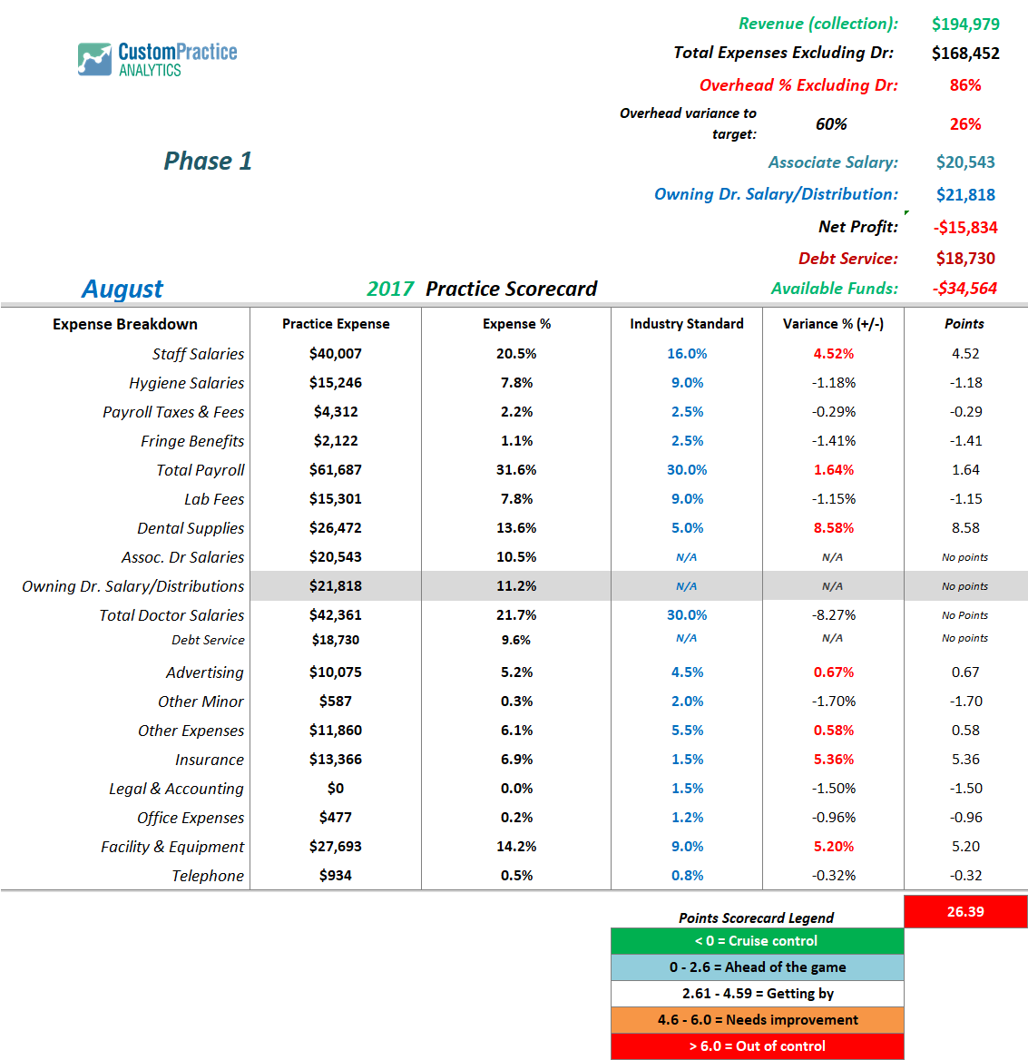
Tale of 2 Practices: Practice 1 Slide 2

