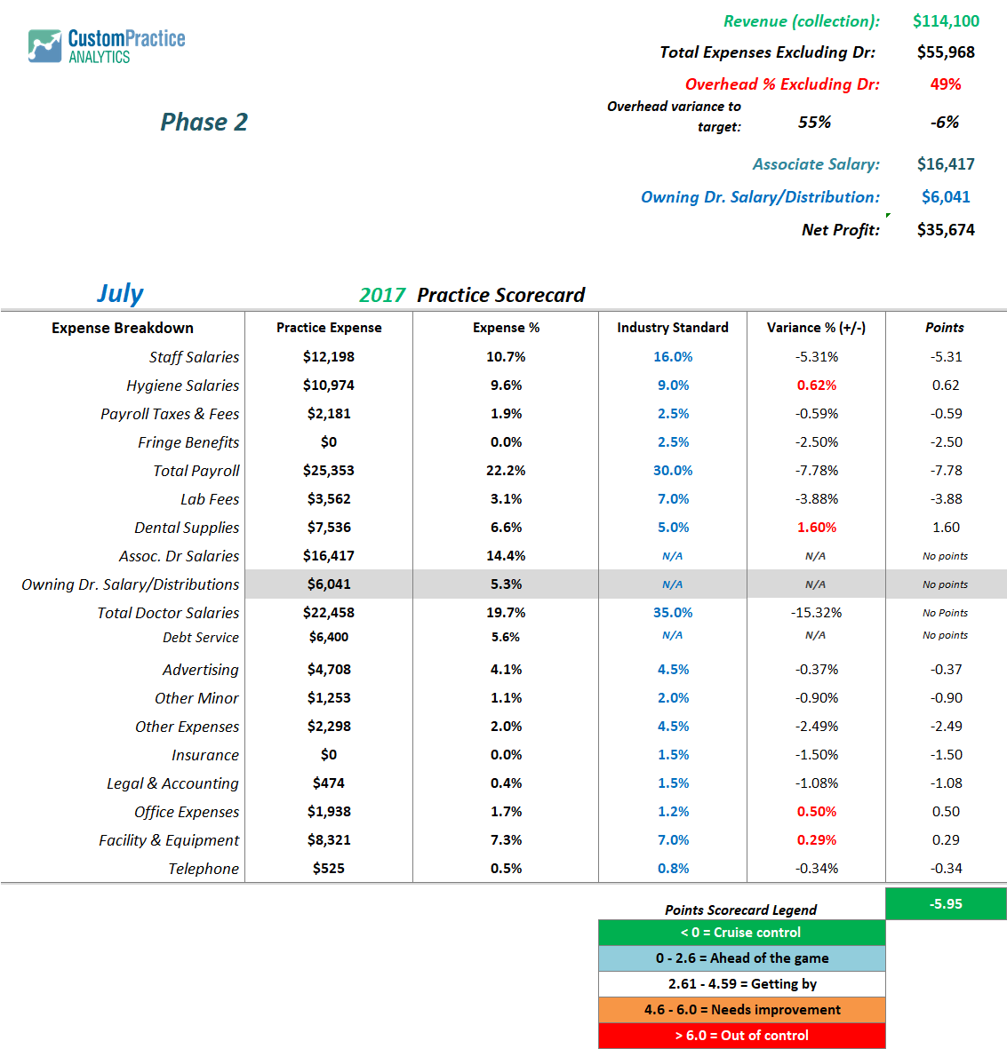
Tale of 2 Practices: Practice 2 Slide 1

