Internal Marketing Strategies

The best marketing is probably marketing to your own patients, and a side benefit is it is usually the cheapest and most effective. The people that walk through your door already know you, like you, and keep coming back. It is best to capitalize on that respect and hope to multiply that to their friends. So here’s what I do, along with the help of my marketing director, Ryan Gross. If you have questions about sourcing products, cards, etc...reach out to him.

First of all, you should have a Brand Book.See here for design philosophy, colors, & fonts.

- Patient Experience:
  - Must be Amazing
    - Obviously you must have a great patient experience from beginning to end. A lot of that starts from becoming human. Go with real personal interaction, CARE about your patients, and just work on connecting with people at a deeper level. If you do that, no matter how you execute it, you will generate patients who think you are amazing...and that’s where it starts.
  - Scripts for phone
    - There are only a few categories where most callers fall into...work to develop scripts that follow all those. This should be in your operations manual.
  - Transfer of Trust scripts
    - In each section of the patient experience, you should have a transfer of trust. This should be a script where you edify who you’re handing off to. This should also be in your operations manual.
  - Texting/Voicemails after difficult procedures(Implants, Endo, Extractions, Sedation)
    - After a difficult procedure, the doctor or staff should text or call patients who had a particularly difficult procedure. This means a lot to patients and is highly recommended. If you don’t want patients to have your direct cell phone number, you can always get a Google phone # to use for patient-only contact. Some services do this automatically like Modento.
  - Continuity of Brand In-Office
    - Internal Office Paperwork
      - Brochures and items that are custom branded do your office. These could include brochures on extractions, implants, sleep apnea, caries risk, periodontal risk. Examples are shown:
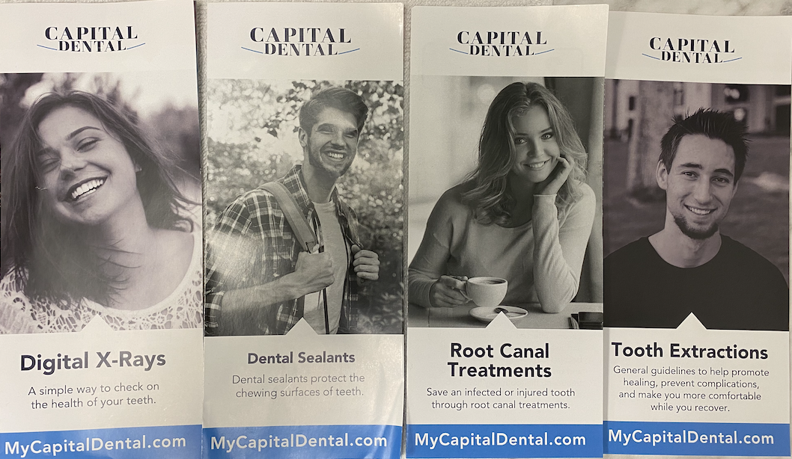
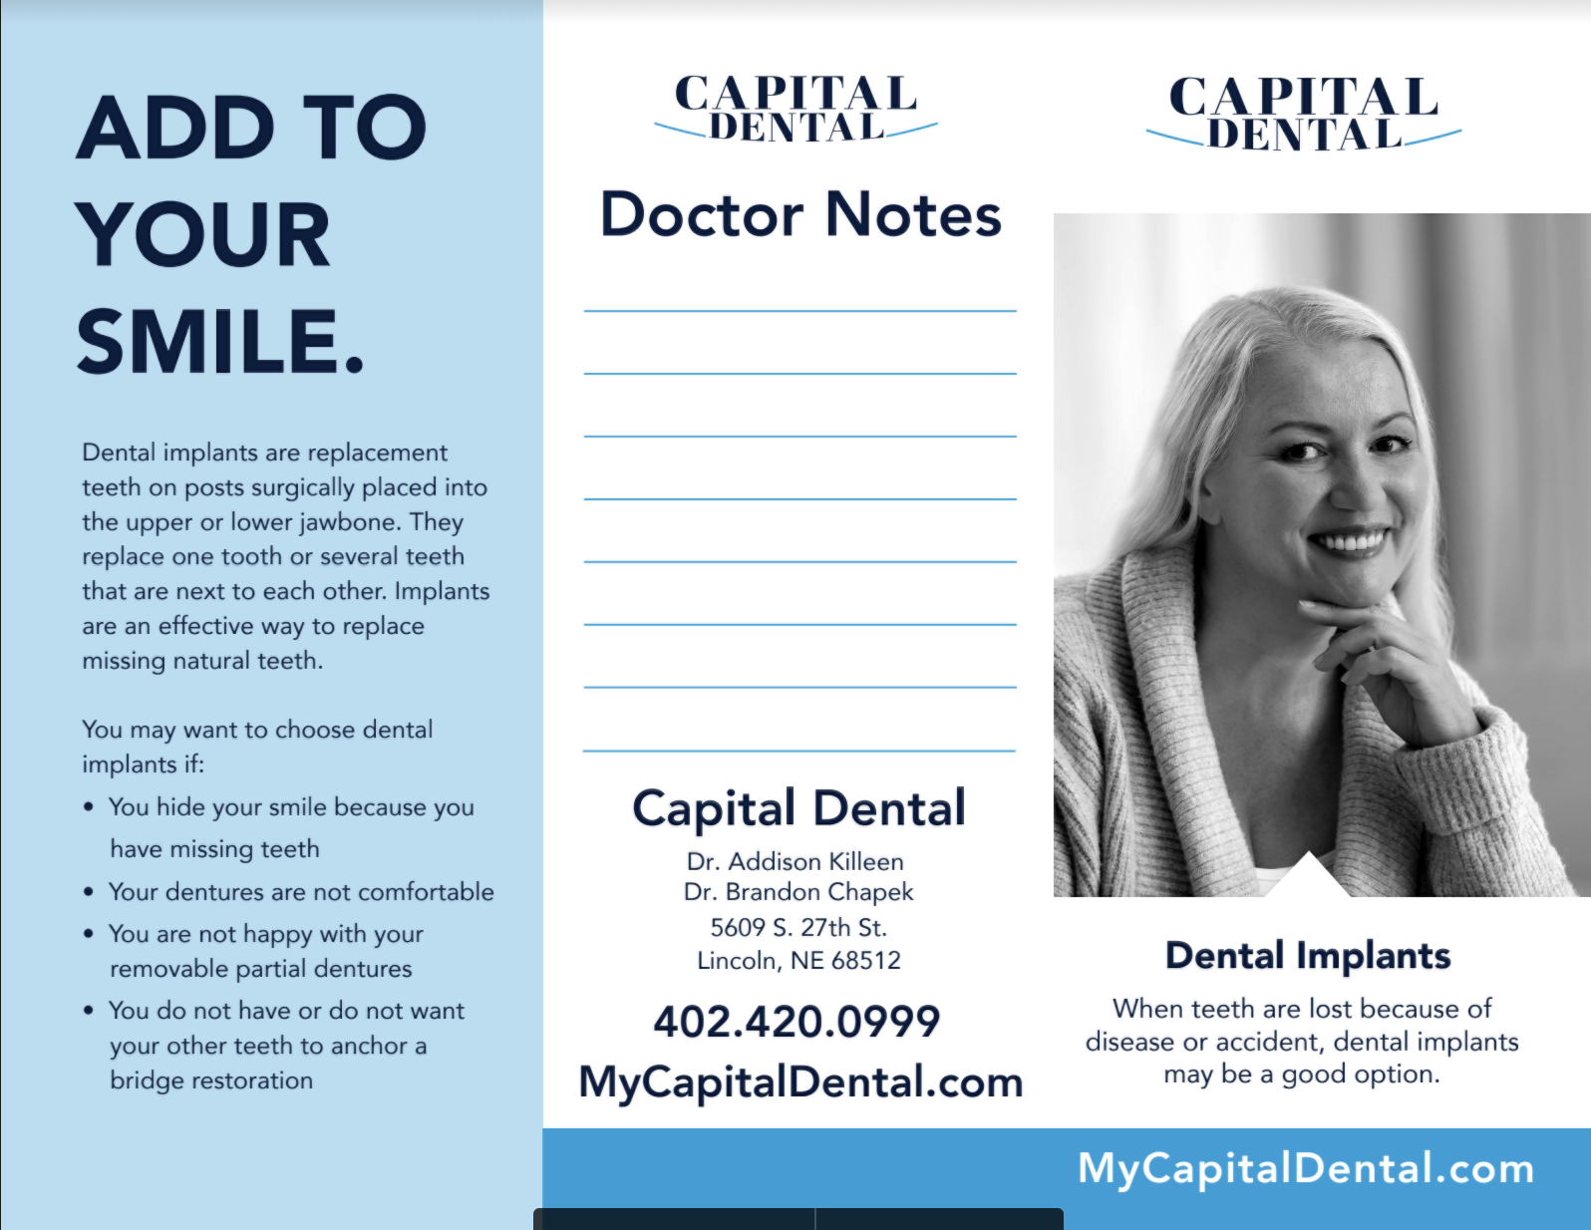
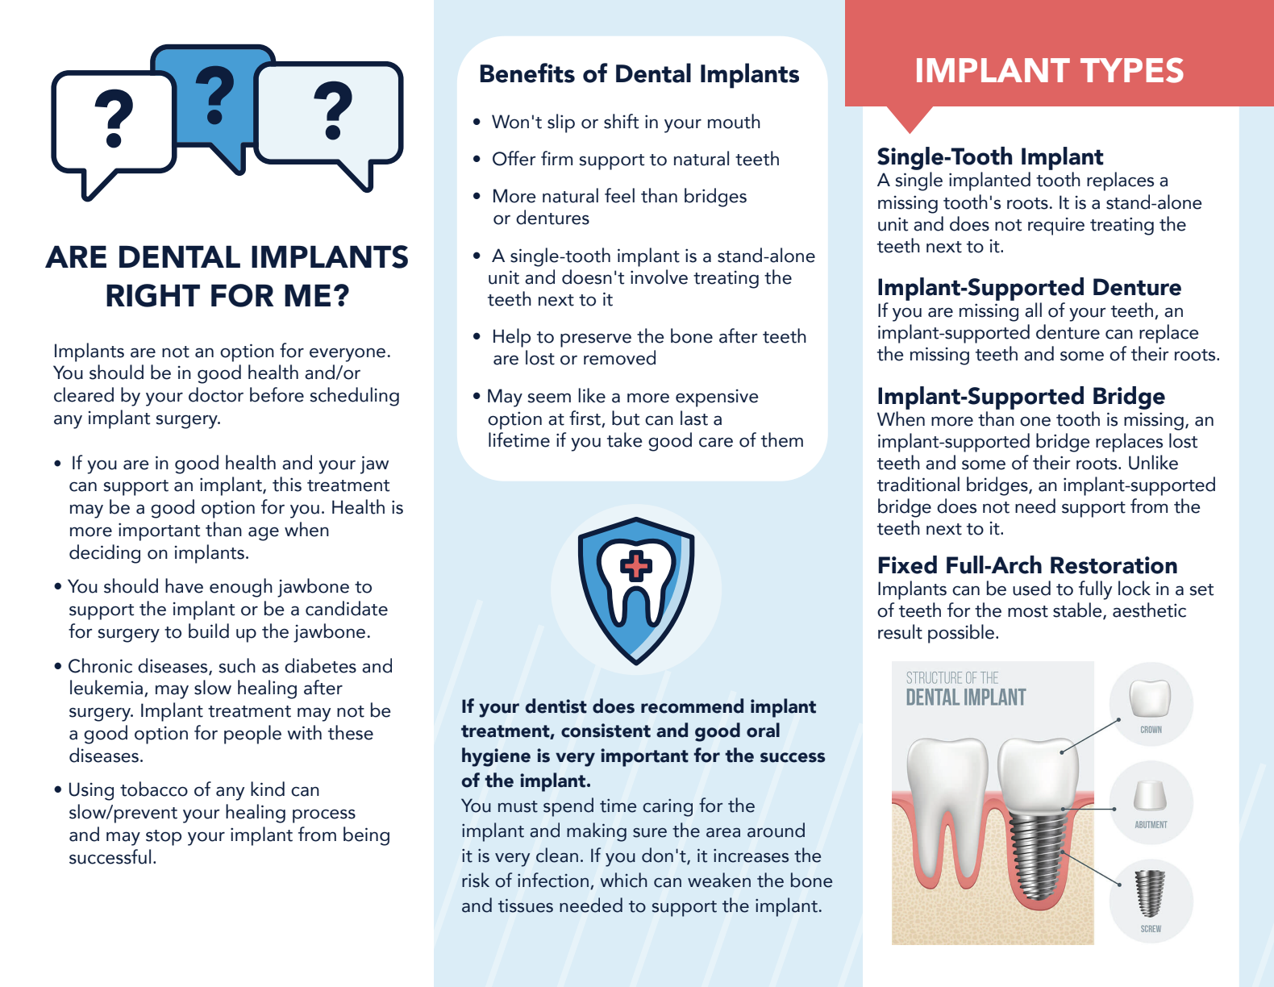
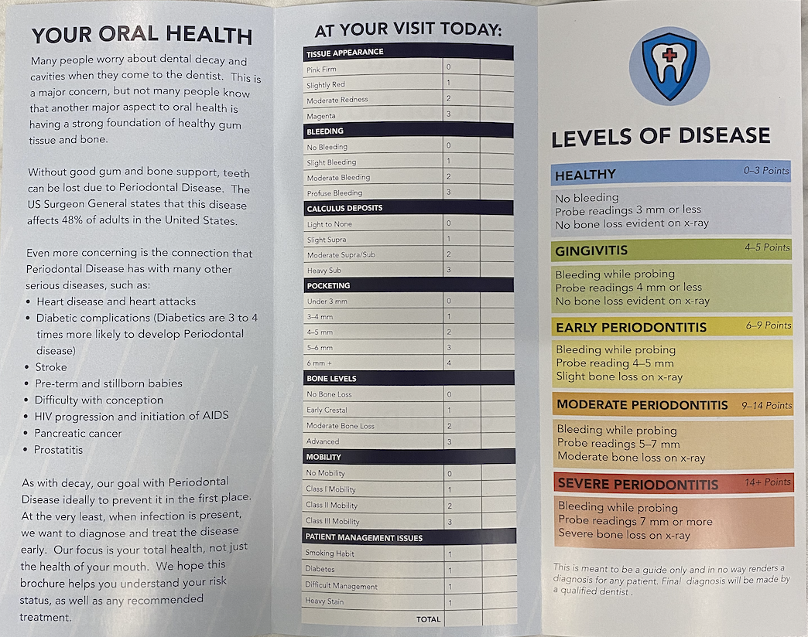

    - Business Cards/Reappointment Cards
      - Custom Business cards are commonplace nowadays. Remember that the quality of card is directly tied to the quality of perceived care they will receive in your office. Do not go cheap on these, splurge for the higher quality card, higher feel, heavier paper, etc. Also make sure they look amazing and do not have pixelated images or poor quality printing.
      - 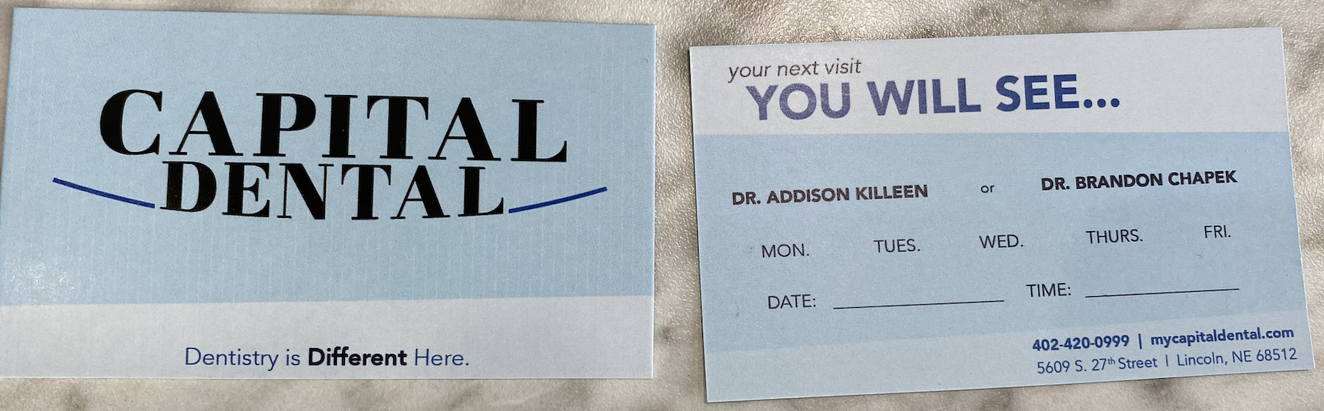
- Patient Giveaways:
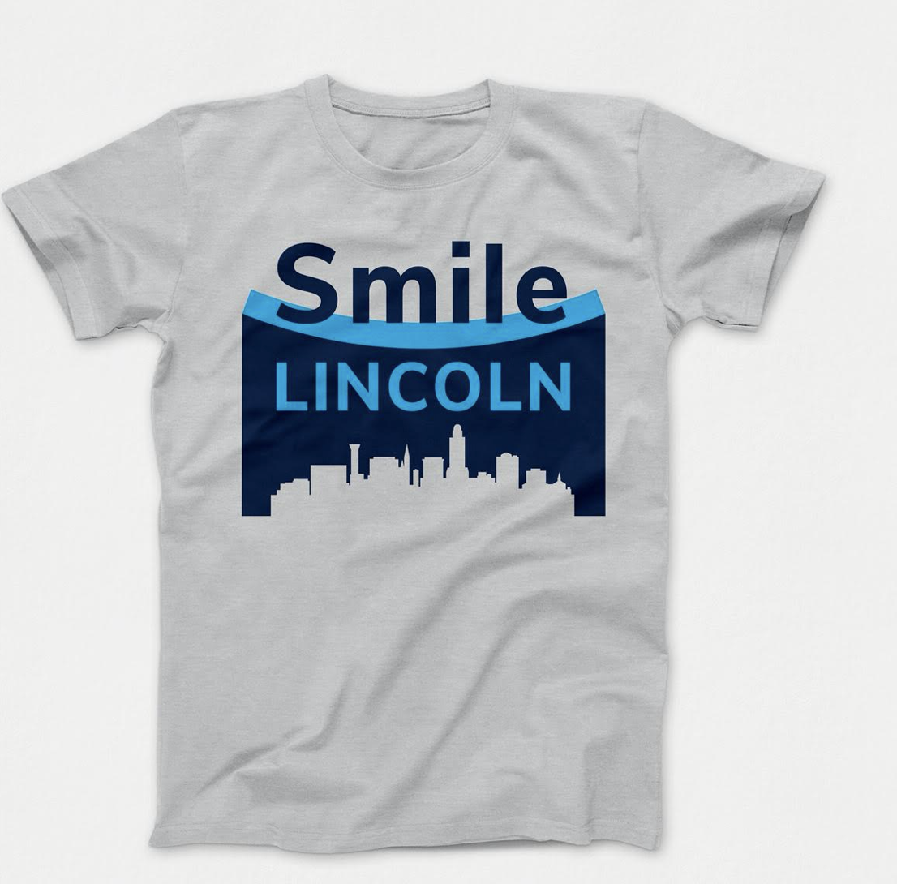
  - Tshirts
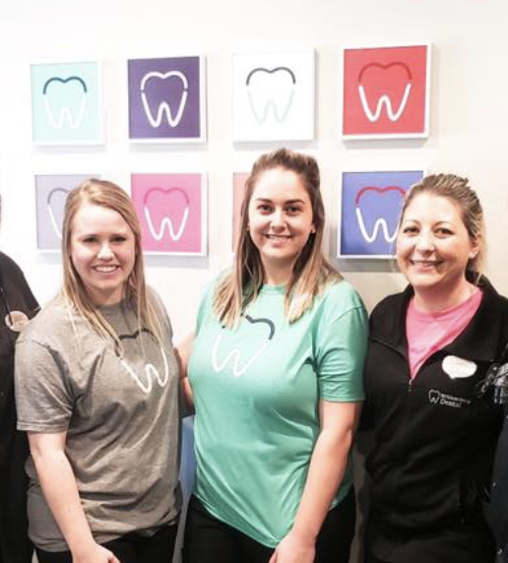
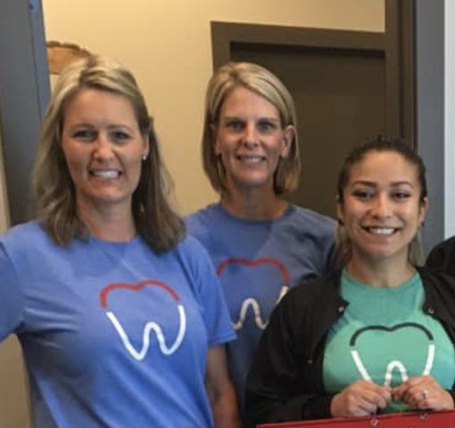
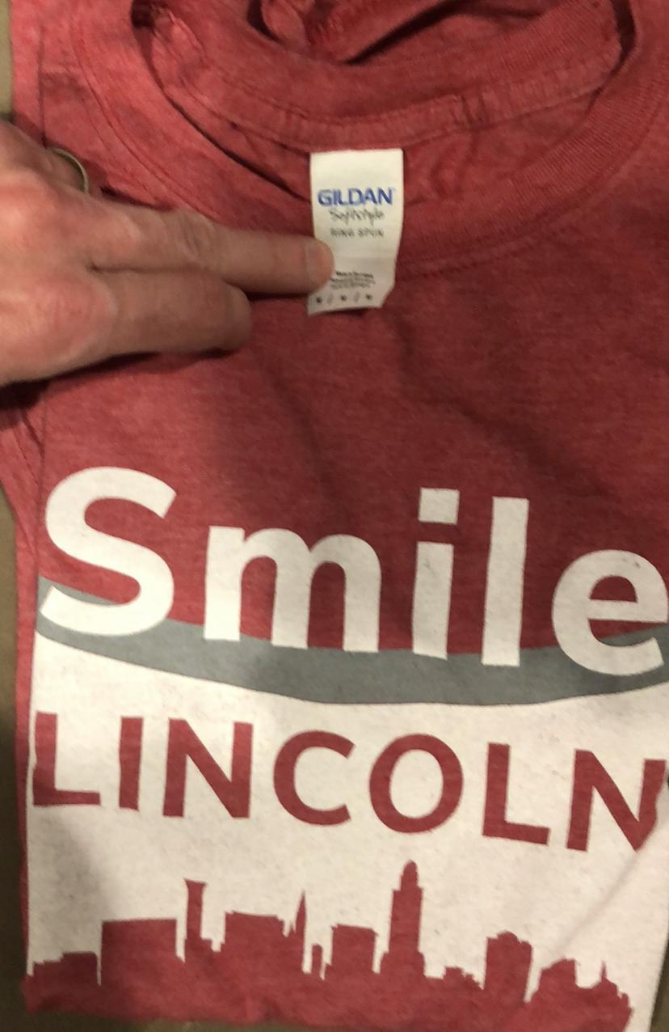
    - In our office we give away t-shirts randomly. We design t-shirts every few months that have neat images on them for the season. They are almost considered a collectible item because of the changing colors and such. Staff love them, and when given out, they are rolled up, tied with a bow, and with a card. (About $6.50 per t-shirt is the cost.) It is more expensive than other options, but they also become walking billboards for you.

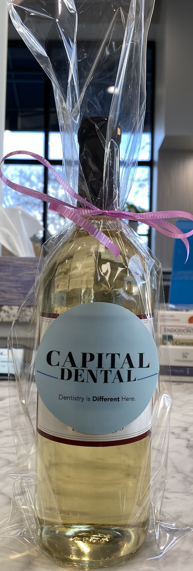
  - Wine
    - We go to Trader Joes or other stores and buy cheaper bottles of wine. Usually $3.50 or less per bottle, and then wrap them in a clear plastic bag from Amazon.com, and put a nice sticker on the bottle, and tie up with a bow. We give out about 1 bottle per employee per day. It’s part of their checklist to give one out to anyone they want. Very random, just pick a favorite patient that the staff member connected with.

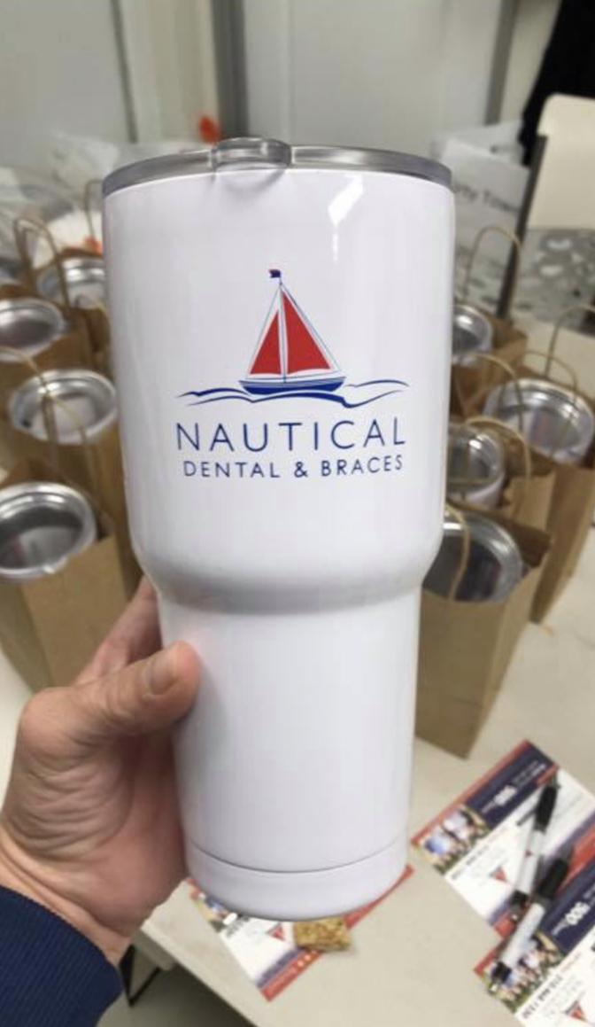
  - Steel-insulated Cups
    - Go to Alibaba.com to purchase, or else use my contact at this company: They are about $4.50 for a 20 oz. mug that is EXACTLY the same as Hydroflask. (They are prohibited from printing Hydroflask on the bottle)
    - Jason Pan - Sales Manager- ZheJiang Skirton Industrial Co.,Ltd Jason@zjskirton.com

- Google/Facebook Reviews:
  - Swell CX- a must needed addition to get more google reviews
  - Giveaways
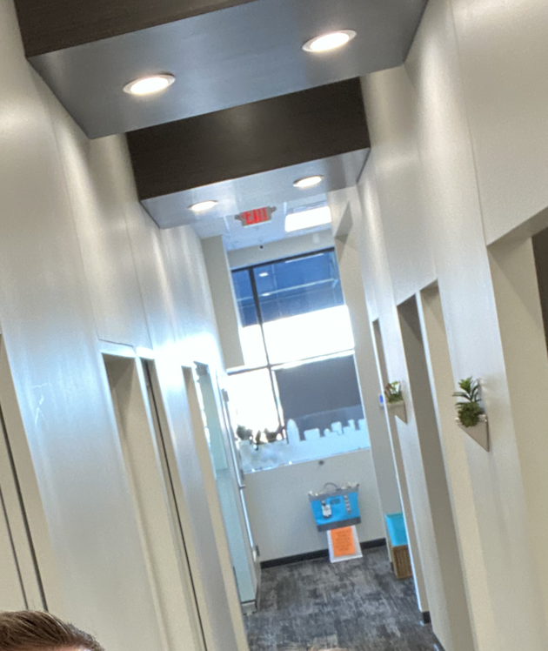
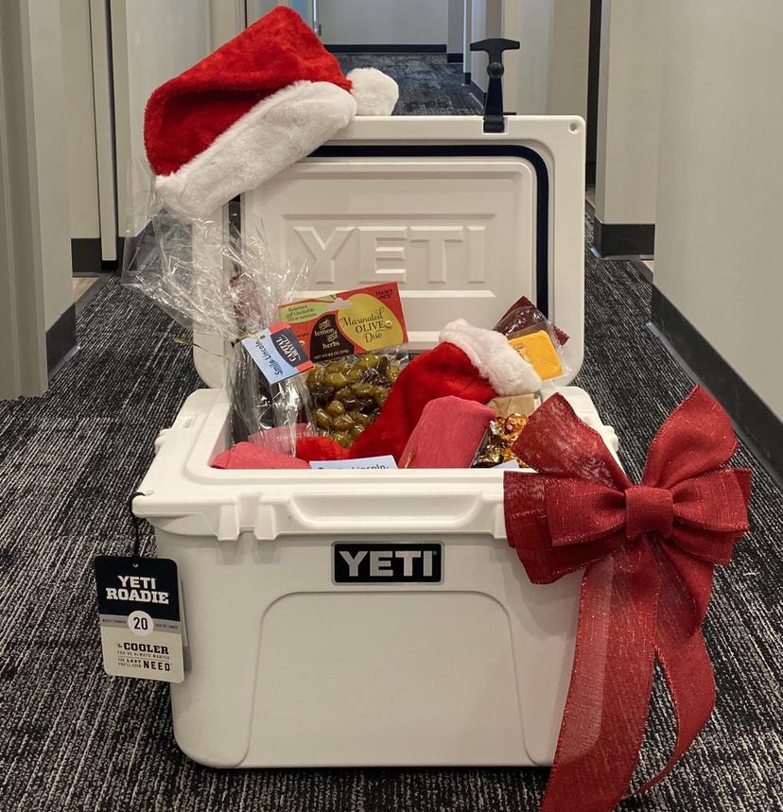
    - Buy a YETI Cooler and put somewhere in the office with a sign that each month or two you will give it away to someone who writes a google review
  - Email Batching to patients
    - Pull all Emails from the past 6 months, send them emails (Usually 40-50 a day to not get put into a spam-mode on the account and get locked). These emails should thank them for being a patient, and remind them how important google reviews are to your business.

- Cards to Patients:
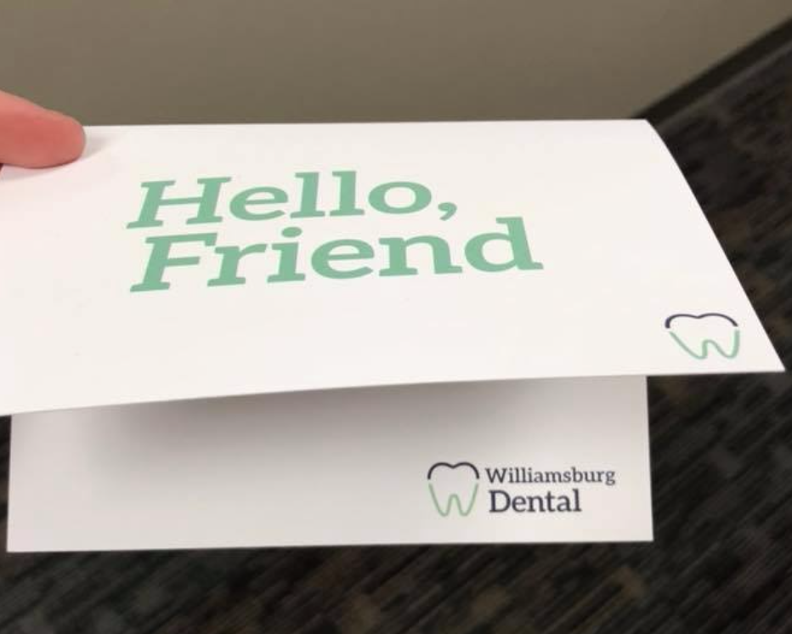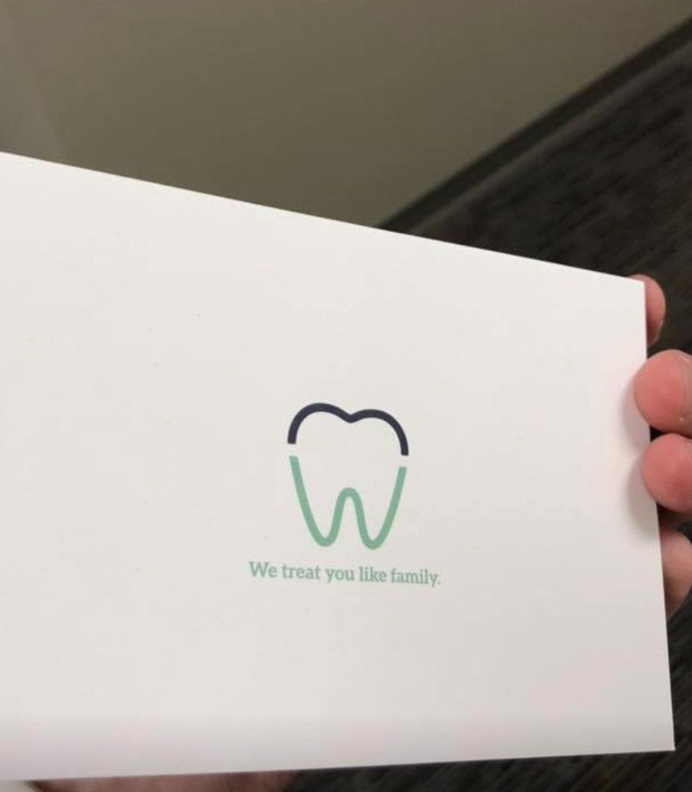
  - New Patients
    - Custom printed cards with a generic message where you can write any message. Must be high quality card-stock

Dear (patient),

Thank you soo much for referring a friend to our clinic recently. It means a lot that you trust us with your care, and in turn tell other people about us. We appreciate it and want you to grab a coffee or smoothie on us today. Enjoy the gift card!

Thanks,
Dr. Killeen, Chapek, and Team

    - Here’s a link to the directions: HERE
  - Returning Patients
    - Same card as above, different text from a patient who followed the doctor from a previous practice:

Thank you so much for choosing Capital Dental!

I’m grateful to see so many familiar faces here at our new office. It means the world to me that you would follow us here for your care.

You’ve brightened my day. I hope this coffee gift card will brighten yours.

Many thanks!

Dr. Addison Killeen
  - Special Occasions
    - Same card as above, but the idea is that when something is happening in a patient’s life, have the staff write a ‘Hello, Friend’ card. The idea is that it just says “Hello, We’re thinking of you”. It could be a difficult time, it could be a celebration. Anything...people like getting a card...and if it’s from their dentist or hygienist...it’s that much more special. No gift in this card, just a message.

