Setup Checklist

2020 EDITION

Dental Success Network

## **Master Checklist**

## **1.** DSN Vendor Discounts & Bridges

## **2.** Providers & List

## **3.** Operatories

## **4.** Schedule Views

## **5.** Procedure List and Fee Schedules

## **6.** Definitions

## **7.** Appointment Views

## **8.**Procedure Buttons

## **9.** Program Buttons

## **10.** Auto Notes Templates

## **11.** Procedure Note Template in Procedure

## **12.** Definitions - Quick Add

## **13.** Setup RX Pad

**14.** Educational Video Tracts for different positions

Master Checklist

|  |  |  |  |
| --- | --- | --- | --- |
| **Before you Begin** | | OD Web Link | Download |
| **Data Paths** | **Make sure the paths to Open Dental Folders work on all computers** | [**Data Paths Setup**](http://opendental.com/manual/paths.html) | **Video & Notes Below  Visit Website for specific Vendor Discounts** |
| **Bridges: - Digital Imaging**  **- Other** | **Program Bridges need to be set up on the server and workstations**   * **Select Digital Imaging software** * **Determine any other 3rd party softwares** | [**Program Bridges**](http://opendental.com/site/programbridges.html)  [**DSN Vendor Discounts**](https://members.dentalsuccessnetwork.com/get-started/reduce-overhead/#vendors) |
| **Clearinghouse** | **Select the clearinghouse you will send e-claims to, then set up.** | [**E-Claims**](https://opendental.com/manual/clearinghouses.html) |
| **Initial Setup** | | OD Web Link | Download |
| **General Practice Information          Scheduling    Fee Schedules            Users and Security** | **Turn on features (Clinics, Medical, EHR)** | [**Show Features**](http://opendental.com/manual/showfeatures.html) |  |
| **Set up Dentists and Hygienists as Users** | [**Provider List**](http://www.opendental.com/manual/providers.html) |  |
| **If using clinics, enter clinic names, addresses, defaults (Only for Multiple Clinic Users)** | [**Clinic Setup**](http://www.opendental.com/manual/clinics.html) |  |
| **Enter practice name, address, default providers.** | [**Practice Setup**](http://www.opendental.com/manual/practice.html) |  |
| **Enter employee names.** | [**Employee List**](http://www.opendental.com/manual/employees.html) |  |
| **Set up Operatories (Assign Dentists, hygienists, clinics)** | [**Op Setup**](http://www.opendental.com/manual/operatories.html) |  |
| **Set up provider schedules. This affects open/close times in the appointment module.** | [**Schedule Setup**](http://www.opendental.com/manual/schedule.html) |  |
| **Create Fee Schedule- Download template and change by %**   * **Mark any hygiene procedures as ‘is hyg. Procedure’** * **Enter any non-standard codes** | [**Procedure Code List**](http://www.opendental.com/manual/procedurecodes.html) | **Fee Schedule Example**  **Non-Standard Codes and Usage** |
| **Customize Definitions and options** | [**Definitions Setup**](http://opendental.com/manual/definitions.html) |  |
| **Printing and Scanning**   * **Set default printers** * **Set default scanners** | [**Printer Setup**](http://opendental.com/manual/printersetup.html) [**Imaging Setup**](http://opendental.com/manual/imagingsetup.html) |  |
| **Create Users, assign groups, assign security settings** | [**Security**](http://opendental.com/manual/security.html) | **Example Security Settings** |
| **Define pay periods and rules for Time Clock** | [**Time Card Setup**](http://opendental.com/manual/timecardsetup.html) |  |
| **Appointments** | | OD Web Link | Download |
| **Views** | **Set up appointment schedule Views, HIPAA Compliant View** | [**Appointment View Setup**](http://www.opendental.com/manual/appointmentviews.html) | **Video and Samples** |
| **Recall** | **Verify default recall types.** | [**Recall Types**](http://www.opendental.com/manual/recalltypes.html) |  |
| **Set defaults for the recall list.** | [**Recall List Defaults**](http://www.opendental.com/manual/recallsetup.html) |  |
| **Charting** | | OD Web Link | Download |
|  | **Set up Procedure Buttons** | [**Procedure Button Setup**](http://www.opendental.com/manual/procedurebuttons.html) | **Video and Document** |
|  | **Auto-Notes** | [**Auto Note Setup**](http://www.opendental.com/manual/autonotes.html) | **Video and Template** |
|  | **Procedure Notes and Notes Standard for Every Procedure** | [**Procedure Notes**](http://www.opendental.com/manual/procedurenotes.html) |  |
| **Preferences and Customization** | | OD Web Link | Download |
|  | **Set default preferences for each module** | [**Module Preferences**](http://www.opendental.com/manual/modulesetup.html) | **Change Setting** |
|  | **Set the title bar, language options, and task list defaults** | [**Misc Setup**](http://www.opendental.com/manual/miscsetup.html) |  |
|  | **For printed claims, set the default claim form. (Advanced)** | [**Claim Form Setup**](http://opendental.com/manual/claimforms.html) |  |
|  | **Define custom background, text, and notification colors.** | [**Definition Setup**](http://www.opendental.com/manual/definitions.html) |  |
|  | **Schedule- set up block scheduling.** |  | **Video and Spreadsheet** |
|  | **Set up Rx Pad** |  | **Video and Notes below** |
| **Install into System** | | OD Web Link | Download |
|  | **Allergies** | [**Allergy List**](http://www.opendental.com/manual/allergiesmaster.html) |  |
|  | **Medications** | [**Medication List**](http://www.opendental.com/manual/medicationmaster.html) |  |
|  | **Problems** | [**Problem List**](http://www.opendental.com/manual/problemmaster.html) |  |
|  | **Referrals** | [**Referral List**](http://www.opendental.com/manual/referralsetup.html) |  |
|  | **Dental Laboratory List** | [**Lab Setup**](http://www.opendental.com/manual/laboratories.html) |  |
| **FINAL MUST-DO** | **BACKUPS - Cloud and Local** |  | **Video** |

## 

## 

## **1.** DSN Vendor Discounts & Bridges

[**LINK to Discounts**](https://members.dentalsuccessnetwork.com/get-started/reduce-overhead/#vendors)

* Add-On Softwares to Consider
  + Flex Mango Phones
  + Modento
* E-Claims
  + Dental X-Change
  + Renaissance
* ApteryX
  + X-Ray Imaging

## **2.** Providers & List

* Fill out the list below in preparation to input all providers:

|  |  |  |  |
| --- | --- | --- | --- |
| Provider List | | | |
| Doctor 1 | Name: | DOB: | License State: |
| Abbreviation: | State Rx: | DEA: | License #: |
| Medicaid ID | NPI: | Color Choice: |
| Hourly Production Goal: |  |
| Doctor 2 | Name: | DOB: | License State: |
| Abbreviation: | State Rx: | DEA: | License #: |
| Medicaid ID: | NPI: | Color Choice: |
| Hourly Production Goal: |  |
| Doctor 3 | Name: | DOB: | License State: |
| Abbreviation: | State Rx: | DEA: | License #: |
| Medicaid ID: | NPI: | Color Choice: |
| Hourly Production Goal: |  |
| Hygiene 1 | Name: | DOB: | License State: |
| Abbreviation: | State Rx: | DEA: | License #: |
| Medicaid ID: | NPI: | Color Choice: |
| Hourly Production Goal: |  |
| Hygiene 2 | Name: | DOB: | License State: |
| Abbreviation: | State Rx: | DEA: | License #: |
| Medicaid ID: | NPI: | Color Choice: |
| Hourly Production Goal: |  |
| Hygiene 3 | Name: | DOB: | License State: |
| Abbreviation: | State Rx: | DEA: | License #: |
| Medicaid ID: | NPI: | Color Choice: |
| Hourly Production Goal: |  |
| Hygiene 4 | Name: | DOB: | License State: |
| Abbreviation: | State Rx: | DEA: | License #: |
| Medicaid ID: | NPI: | Color Choice: |
| Hourly Production Goal: |  |
| Hygiene 5 | Name: | DOB: | License State: |
| Abbreviation: | State Rx: | DEA: | License #: |
| Medicaid ID: | NPI: | Color Choice: |
| Hourly Production Goal: |  |
| Employee List | | | |
| Name: | | Wireless Phone: | Email Work: |
| Email Personal: | |
| Name: | | Wireless Phone: | Email Work: |
| Email Personal: | |
| Name: | | Wireless Phone: | Email Work: |
| Email Personal: | |
| Name: | | Wireless Phone: | Email Work: |
| Email Personal: | |
| Name: | | Wireless Phone: | Email Work: |
| Email Personal: | |
| Name: | | Wireless Phone: | Email Work: |
| Email Personal: | |
| Name: | | Wireless Phone: | Email Work: |
| Email Personal: | |
| Name: | | Wireless Phone: | Email Work: |
| Email Personal: | |
| Name: | | Wireless Phone: | Email Work: |
| Email Personal: | |
| Name: | | Wireless Phone: | Email Work: |
| Email Personal: | |
| Name: | | Wireless Phone: | Email Work: |
| Email Personal: | |

## 

## 

## **3.** Operatories

|  |  |  |  |  |  |  |
| --- | --- | --- | --- | --- | --- | --- |
| **Op 1** | **Op 2** | **Op 3** | **Op 4** | **Op 5** | **Op 6** | **Op 7** |
| Name? | Name? | Name? | Name? | Name? | Name? | Name? |
| Abbrev: | Abbrev: | Abbrev: | Abbrev: | Abbrev: | Abbrev: | Abbrev: |
| Circle:  **Doc / Hyg** | Circle:  **Doc / Hyg** | Circle:  **Doc / Hyg** | Circle:  **Doc / Hyg** | Circle:  **Doc / Hyg** | Circle:  **Doc / Hyg** | Circle:  **Doc / Hyg** |
| Provider: | Provider: | Provider: | Provider: | Provider: | Provider: | Provider: |

## **4.** Schedule Views

## **Schedule Setup: Download** Spreadsheet(Doubles as Block Scheduling Sheet)

## **5.** Procedure List and Fee Schedules

## **Download** Procedure Codes **&** Fee Schedule

## 

## **6.** Security Settings Examples

## 

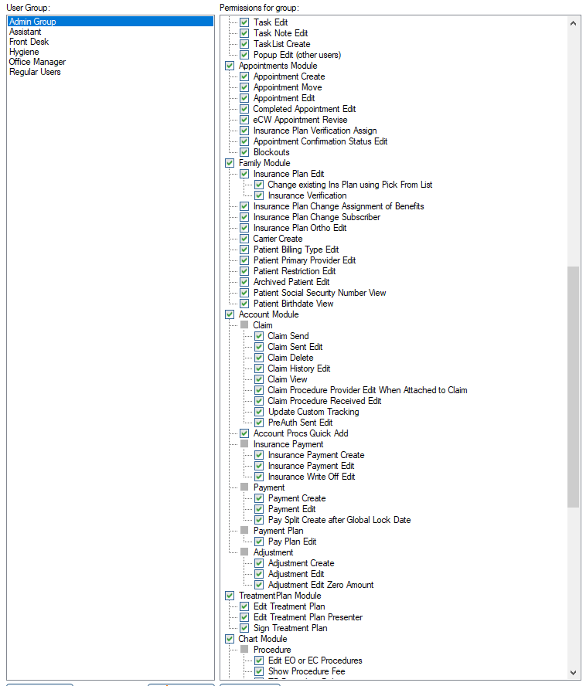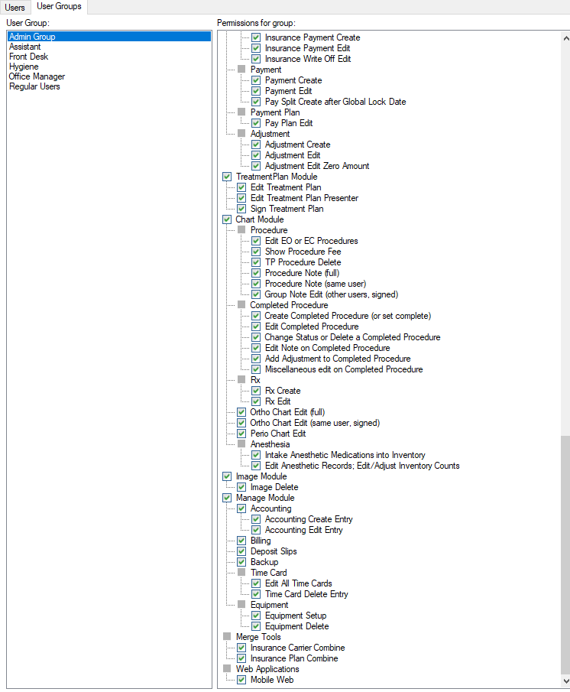

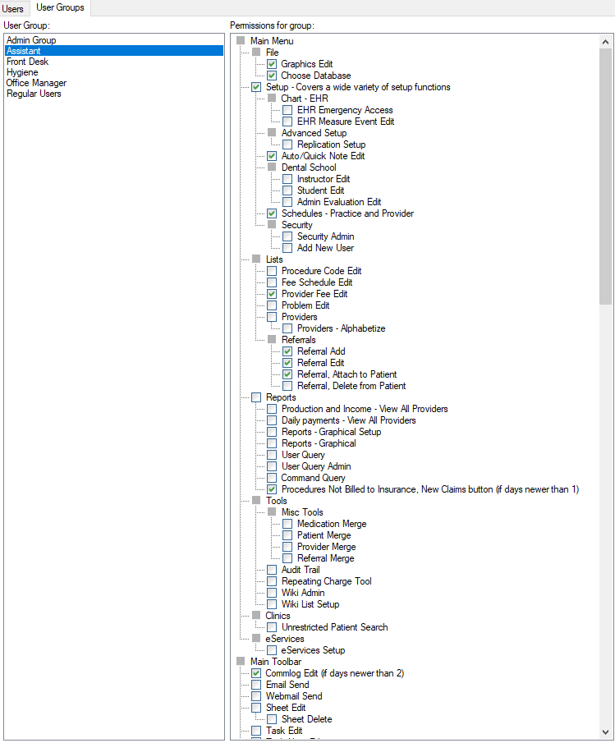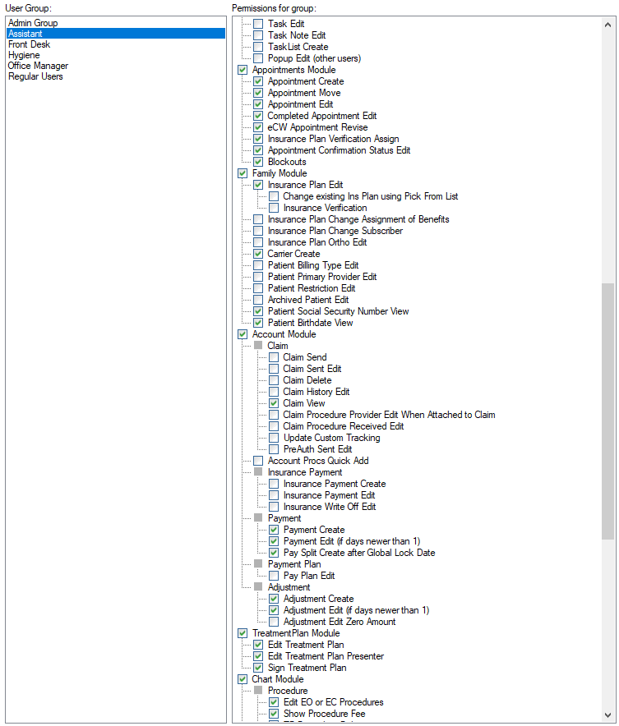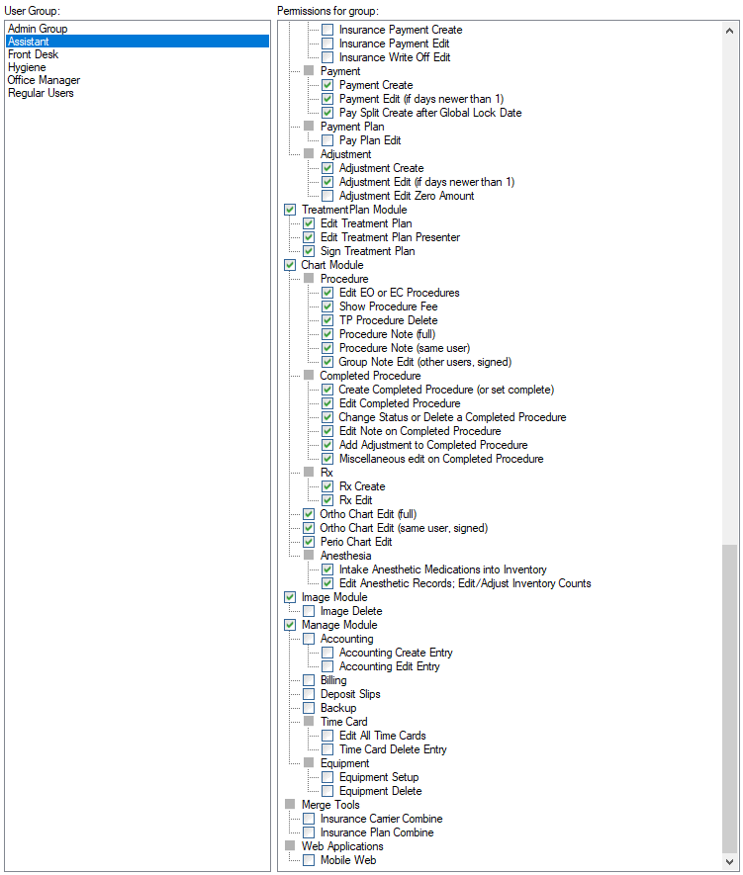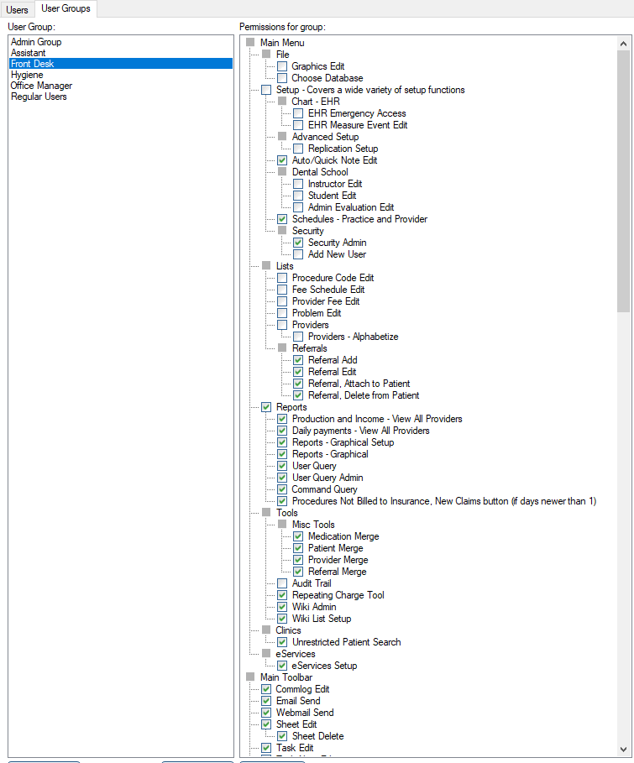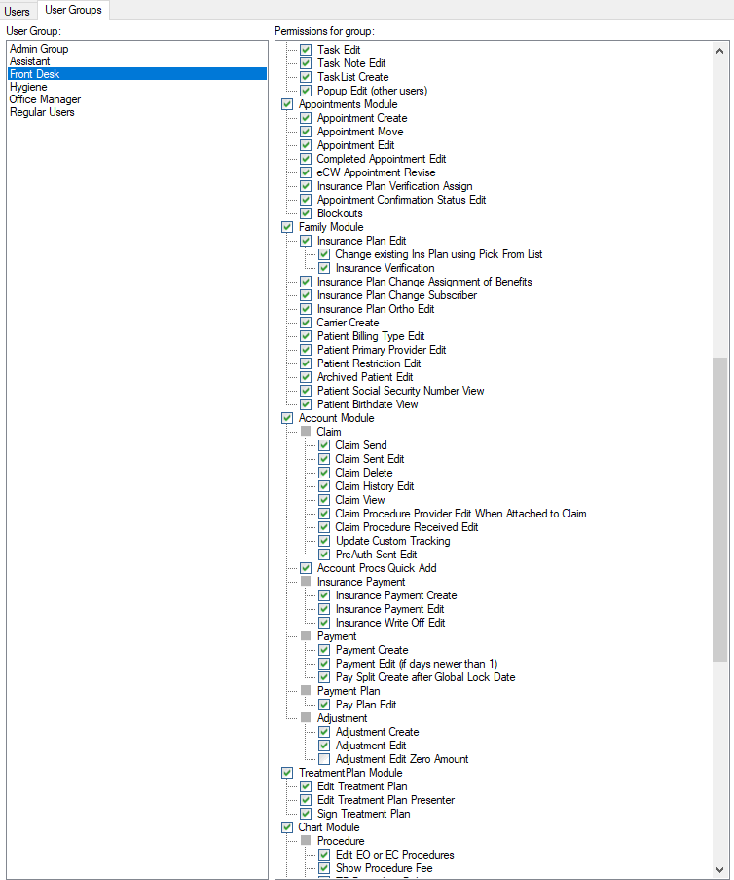

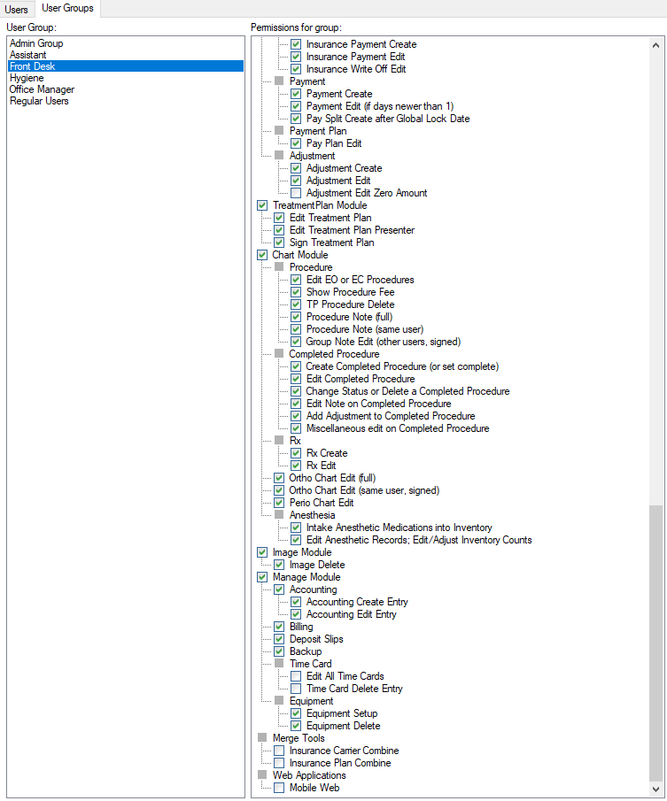

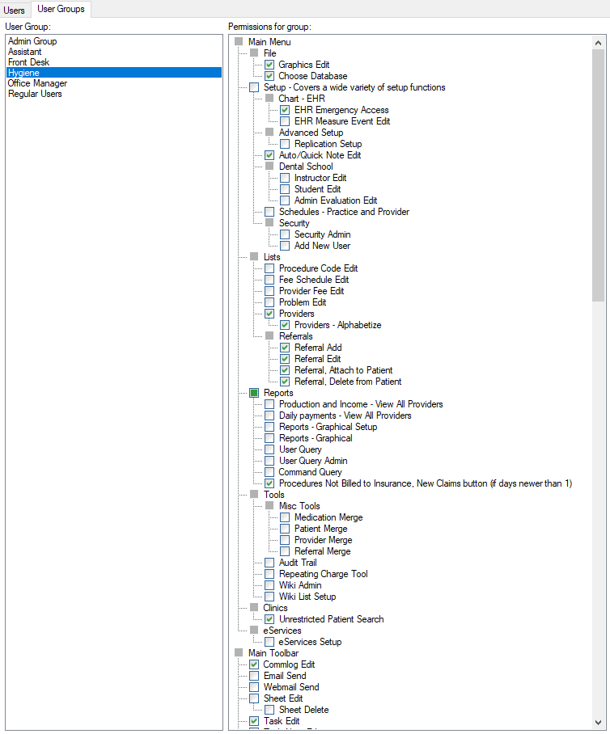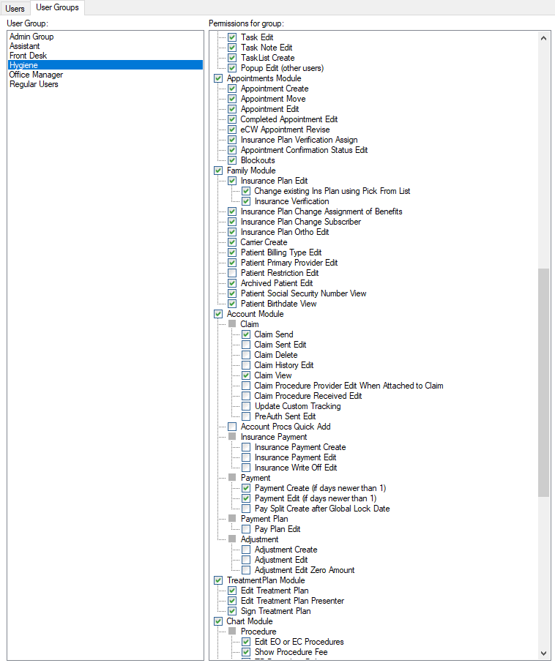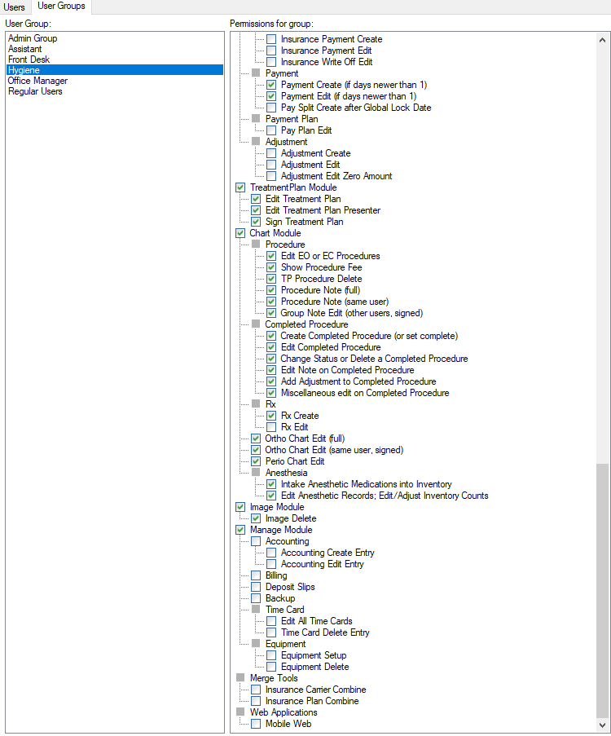

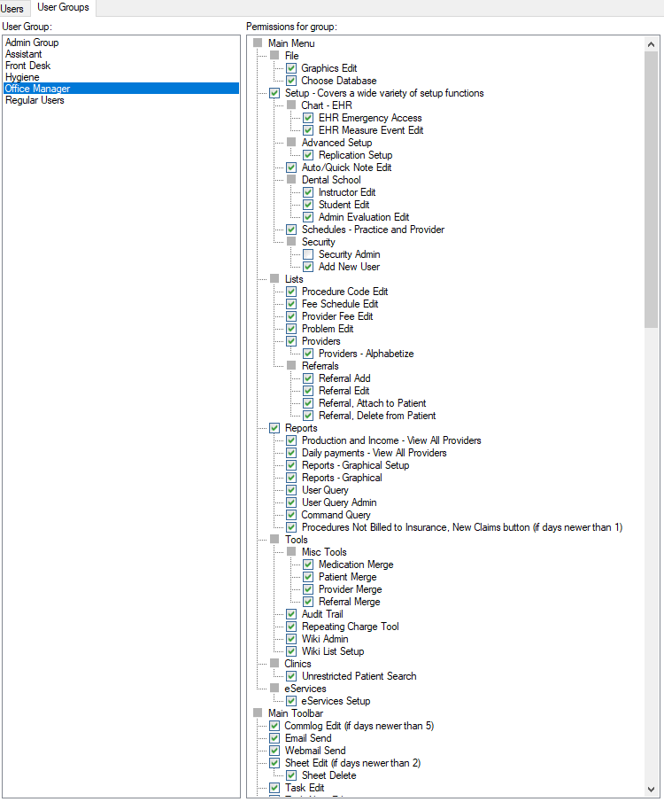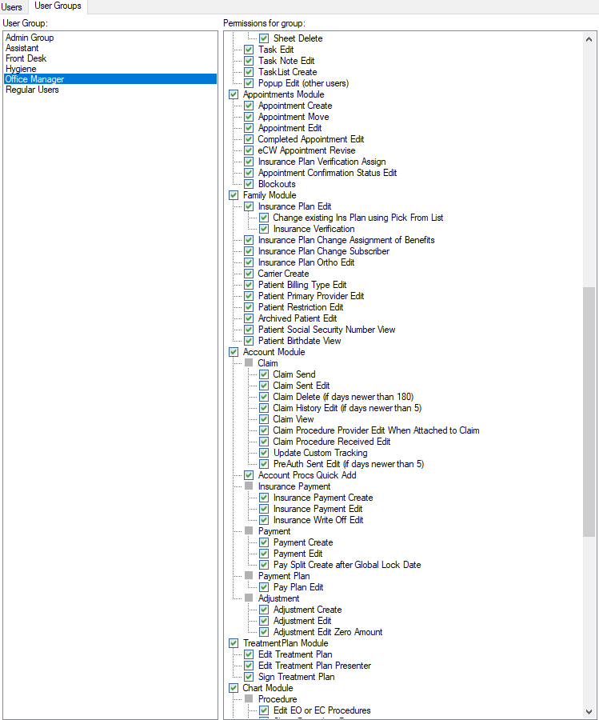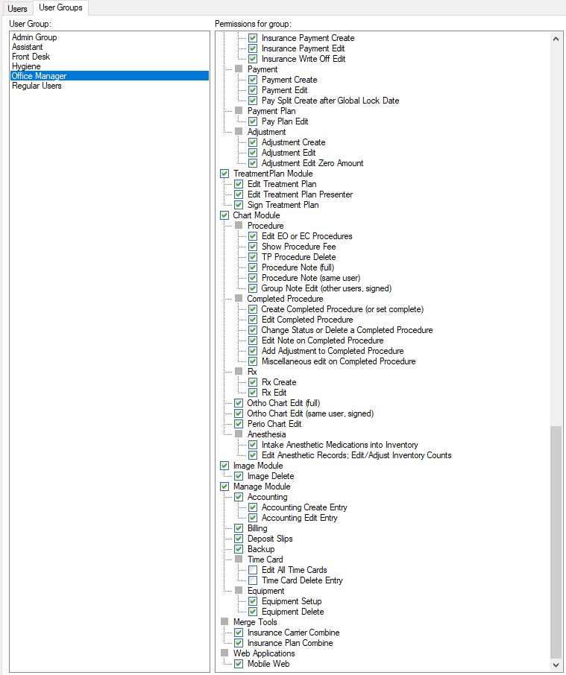

## 

## **7.** Definitions

* Adj Types -
  + Add Employee Discount (-)
  + Check all others to either add or remove ones you don’t think you’ll use
* Appointment Colors
  + Change ‘Practice Closed’ to slightly darker grey
* Appointment Confirmed
  + Add Type 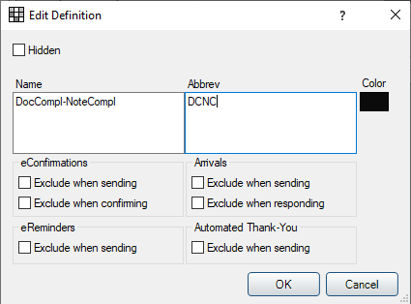
  + This is used for once Doctor/Hygiene has completed their notes
  + Should appear like this:
  + 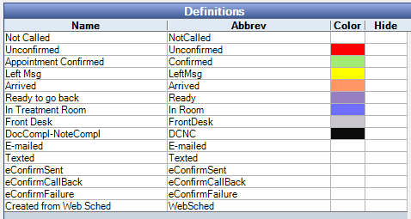
* Appointment Procs Quick Add: see Step 9 Below
* Blockout Types
  + Create all the following blockouts as shown below
  + 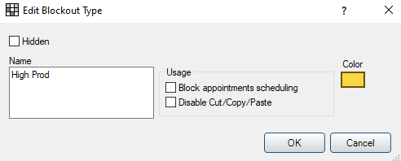
  + Only Click the ‘Block appointments scheduling’ for Lunch and Meeting as shown below
  + 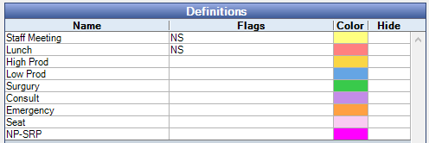
  + Go to Spreadsheet
    - Pick the hours your practice will be open
    - Pick the ideal length of the Planned appointments
    - Pick the ideal XX-OOO-XX Times for ‘captive doctor time’
      * Set the middle of the blockout to be the darker colors
    - Plan out the ideal day/week/ to hit the target numbers for:
      * #s of New Patients per month (then divide by 4 to hit weekly target)
      * #s of High Prod/Surgery/Low Prod blocks to hit daily Production $ target

## 

## **8.** Appointment Views

* Keys to Appointment Views
  + Create 3 types
    - All Information
    - 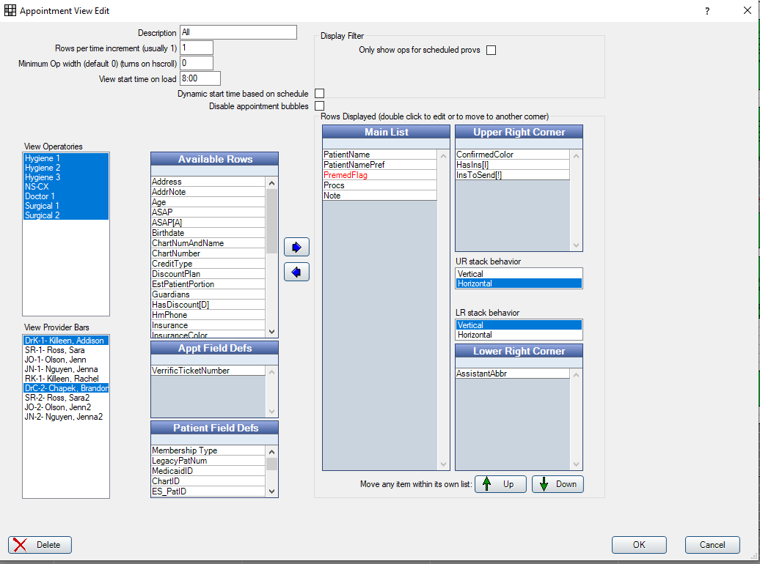
    - HIPAA Compliant View
    - Single Provider Goal and Production View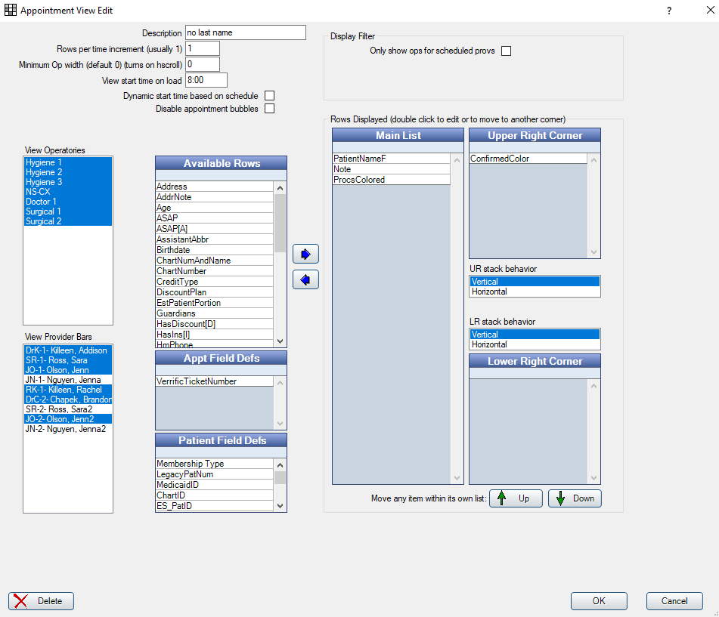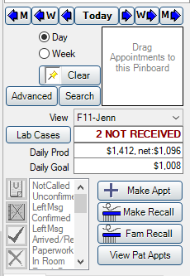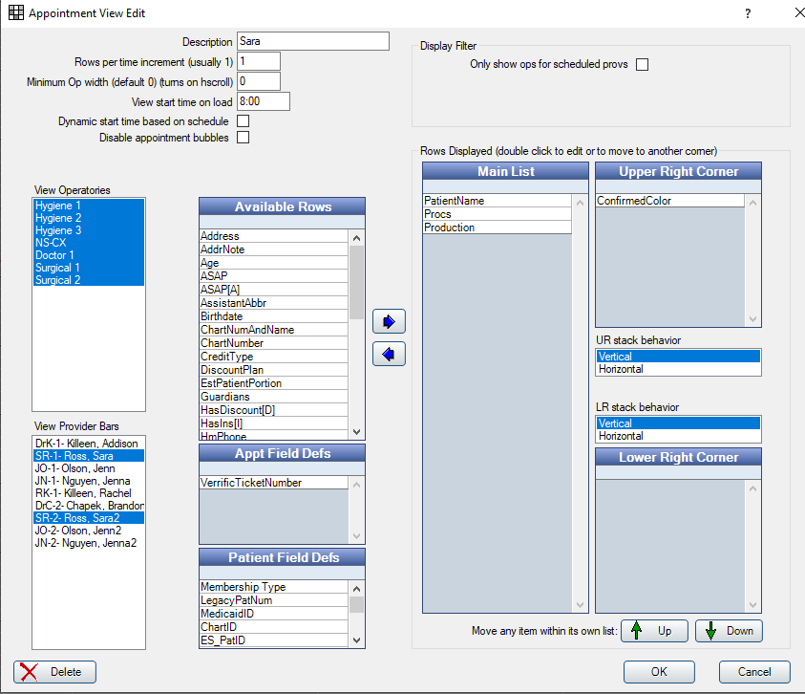
    - Key to this one is that you can still ‘View’ the entire schedule, but only the provider selected under ‘View Provider Bars’ is actually used to figure out production on the ‘Appointment’ Screen

## 

## 

## **9.** Procedure Buttons

* Setup the Categories to match these, or nearly all of these below:
* 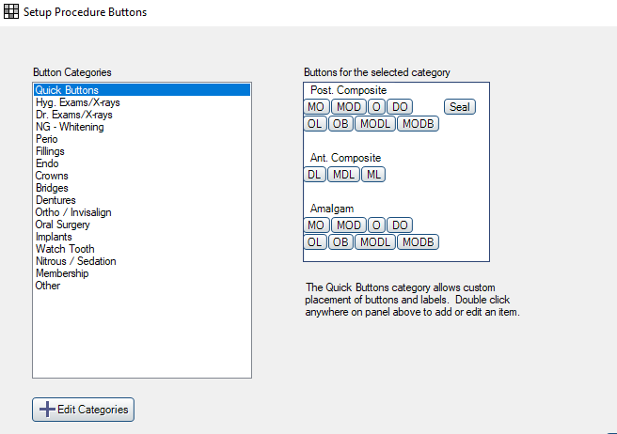
* And under each of these Categories, you will add a Procedure, which Category it falls under, the Image (a 20x20 pixel image- Paint is good to create your own), [**LINK HERE for IMAGE FOLDER**](https://drive.google.com/drive/folders/1YZUbIWzxBdHeHQcBNc1wSyeWpHHBssPZ?usp=sharing), and then
  + Add Procedure Codes you want to ‘Explode’ when you Treatment Plan this procedure
* 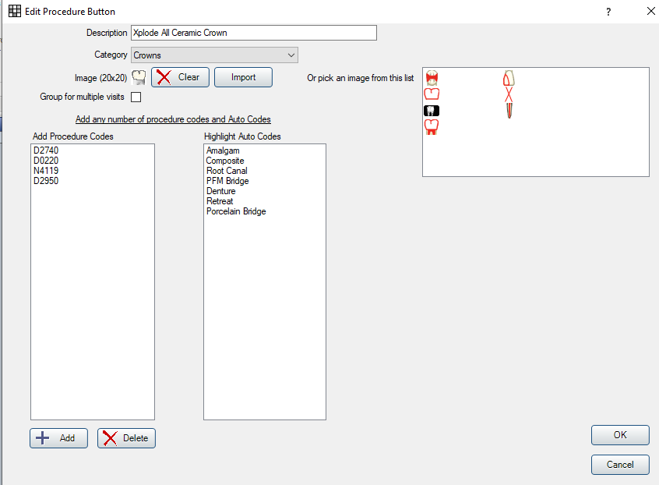

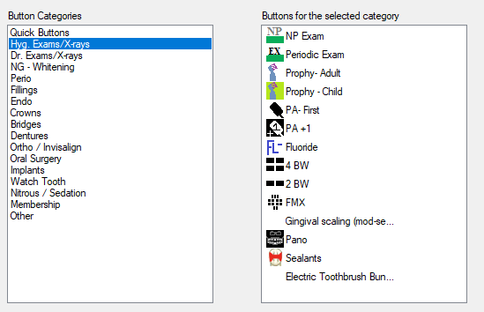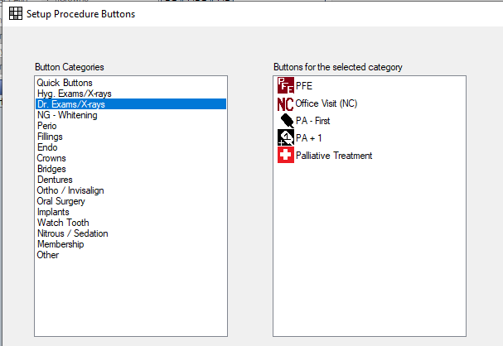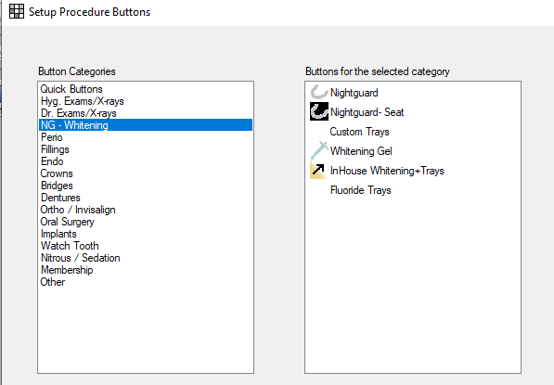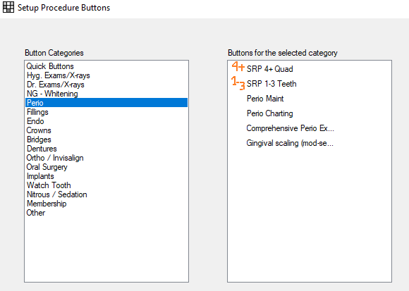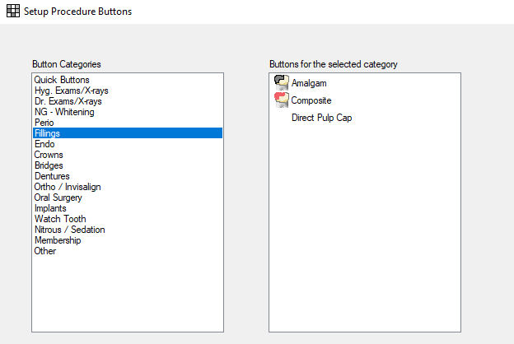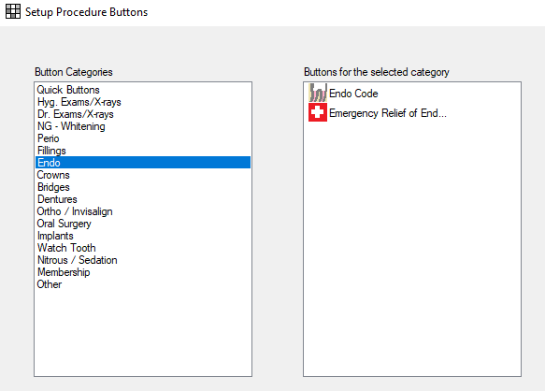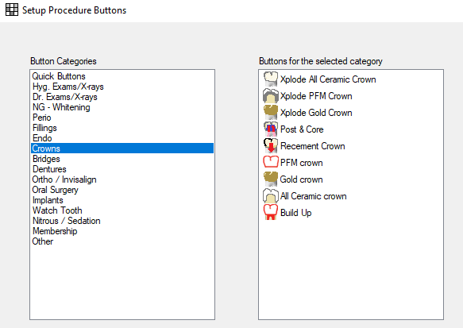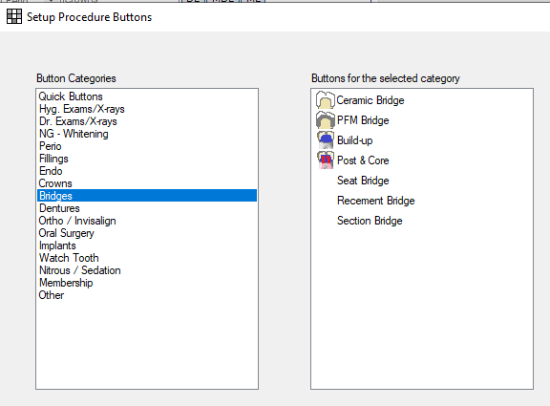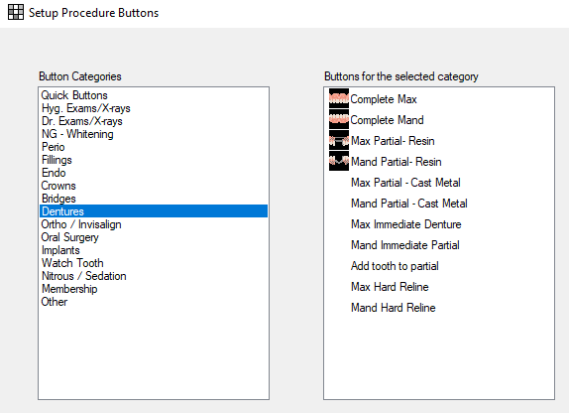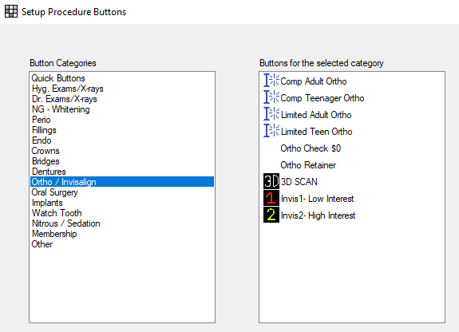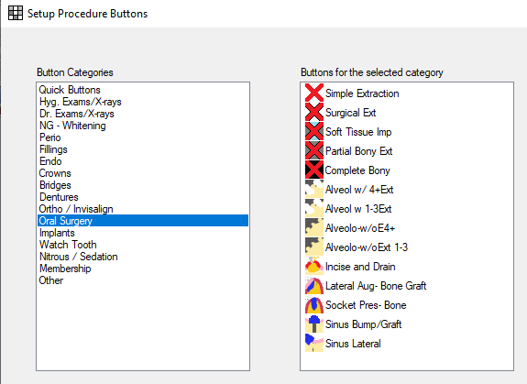

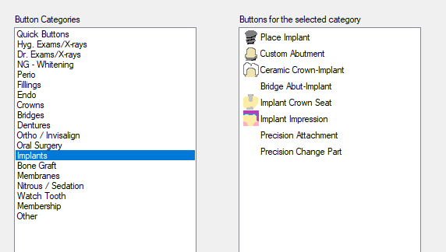

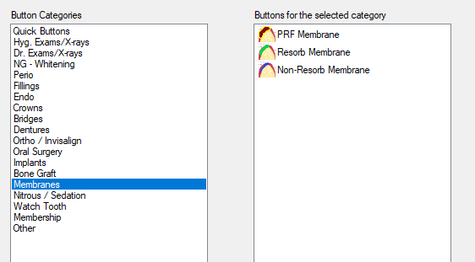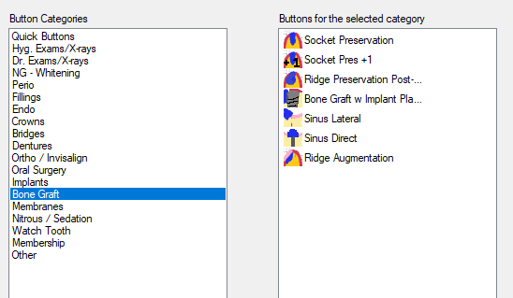

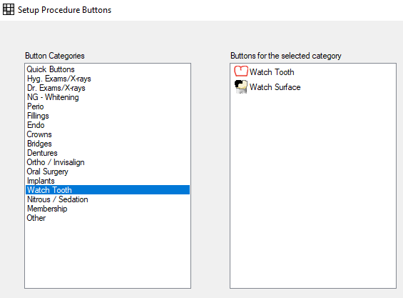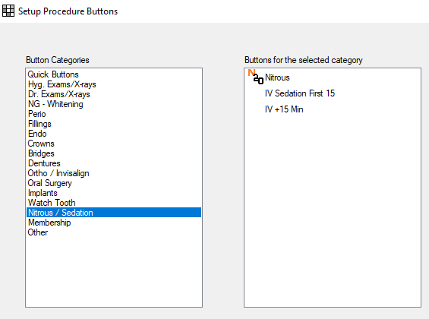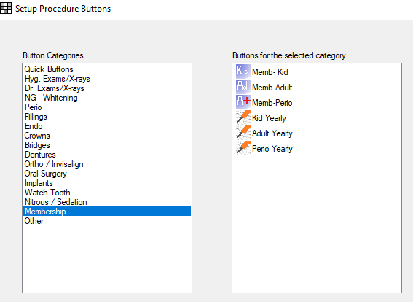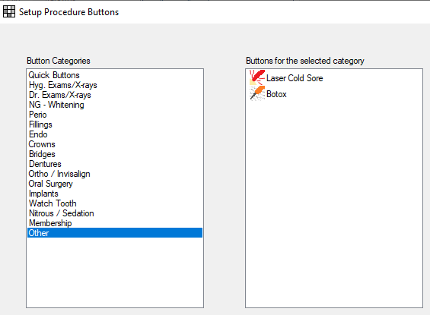

Other procedures that are common:

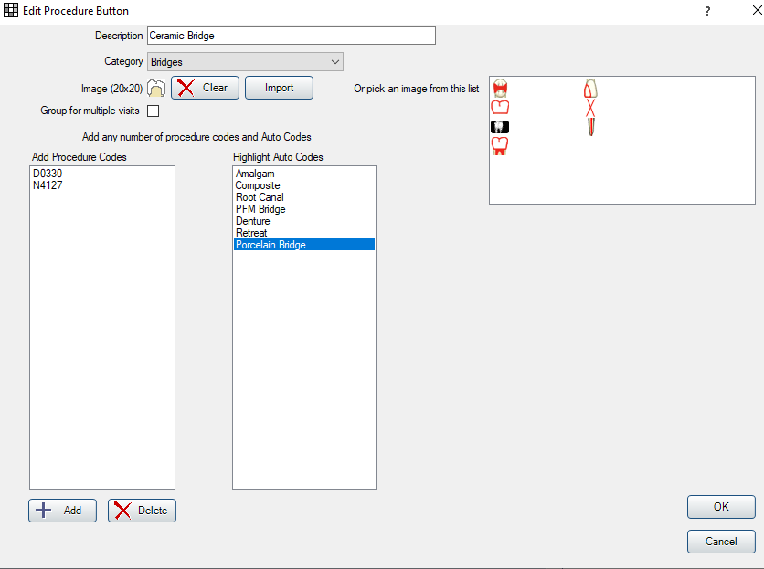

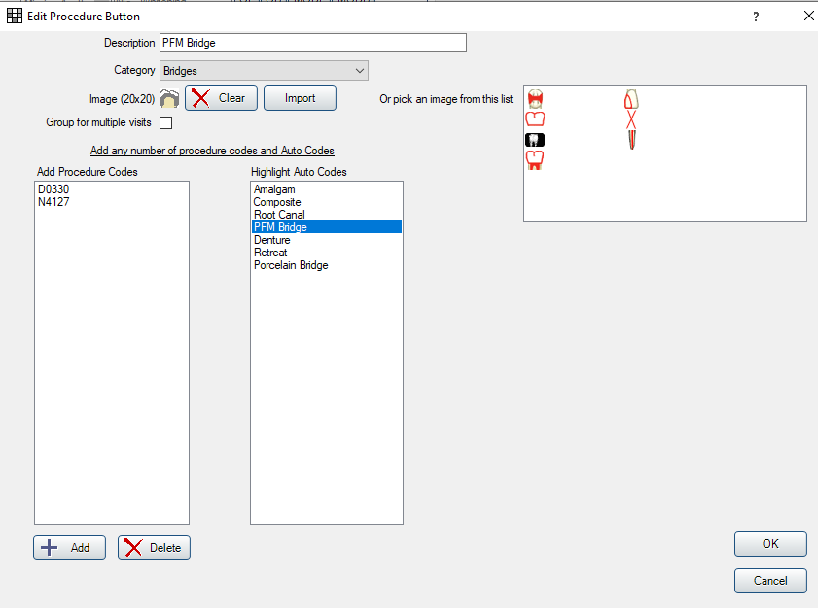

## 

## **10.** Program Buttons

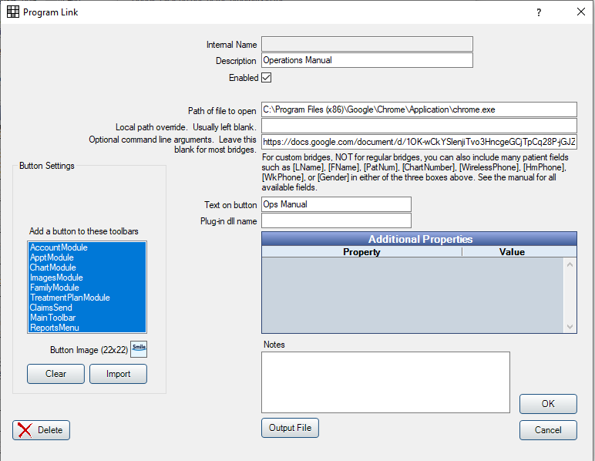

* If you have an operations manual or key documents you want to link to from OD, go to Setttings>Program Links
* Enter in any Description, then Path to open (Like Chrome), then the Optional Command line arguments - the Web URL
* Also you can input a 22x22 pixel image to show.
* Highlight all the places you want the button to show on the left hand column
* Many do this for:
  + Ops Manual
  + Flex or Modento Link
  + Insurance Verification Companies (Verrific will do this for you)
  + Insurance Portals
  + Invisalign Website
  + Itero Doctor Website

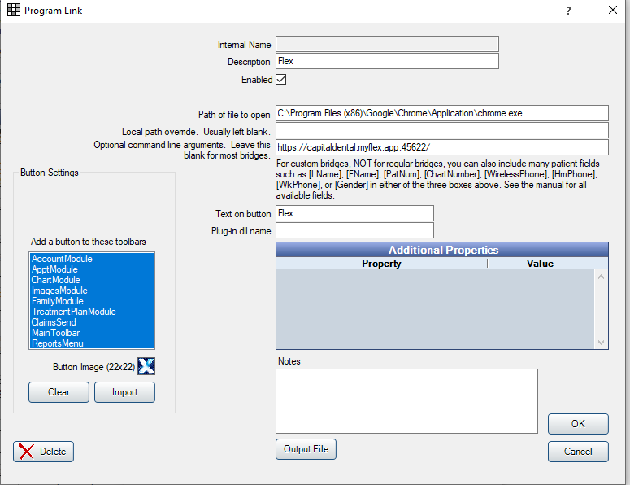

## 

## **11.** Auto Notes Templates

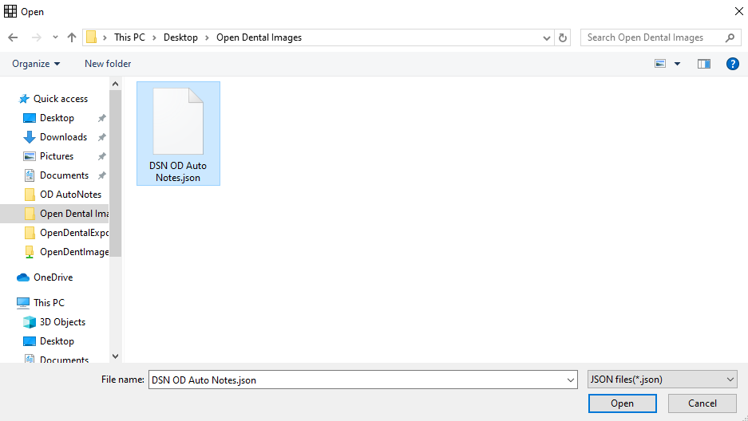

* Go to Settings - Auto Notes
* Delete all existing notes and prompts
* Then go to Import- see image->
* Download a .json file
* You’ll see a message confirming 41 AutoNotes imported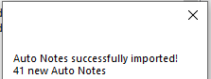
* Go into these ‘Available Prompts’ to Change:
  + Doctor
  + Assistant
* Review all other prompts for types of etch, anesthetic, composite, materials, etc. that are unique to your operation

## 

## **12.** Procedure Note Template in Procedure

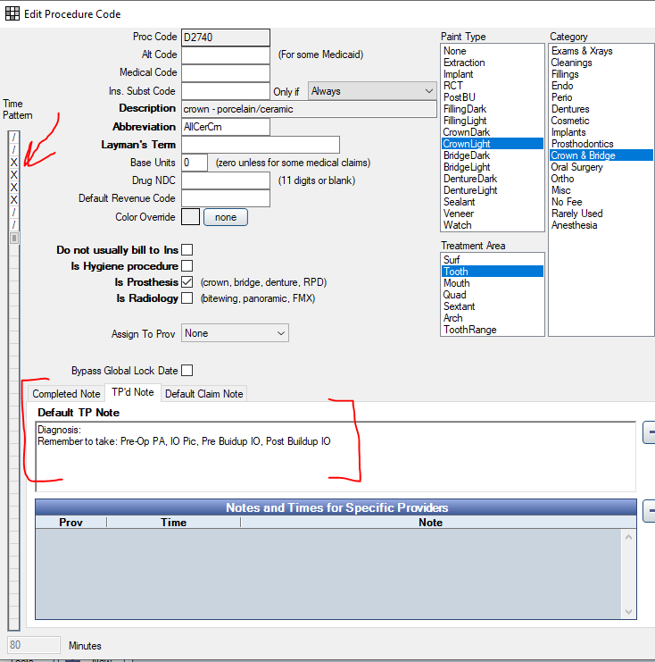

* Make sure to add these notes into any crown you do
* And for Crown Seat procedures, Add:
  + “Post op: Take IO Pic & BW”

## 

## **13.** Definitions - Quick Add

* Add in these Definitions to the Procedure Quick Add Buttons
* 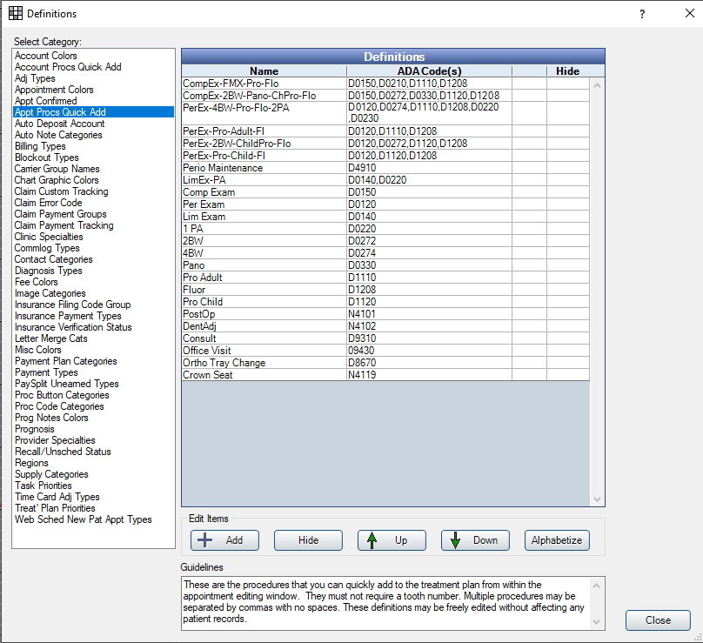

## 

## 

## **14.** Setup RX Pad Sheet and Routing Pad Sheet

* Get icon of your Practice Logo, put on Desktop
* Setup-Sheets
  + Move the RX pad into the custom column, then edit to be like this shape:
* 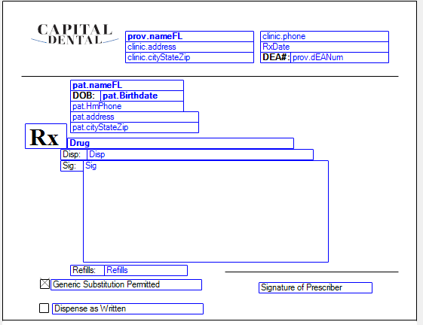

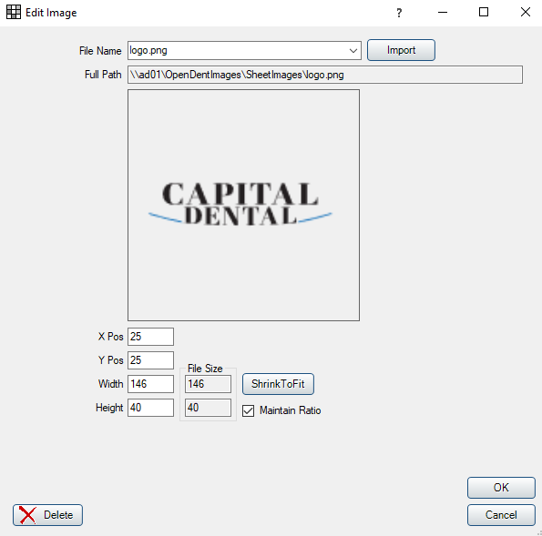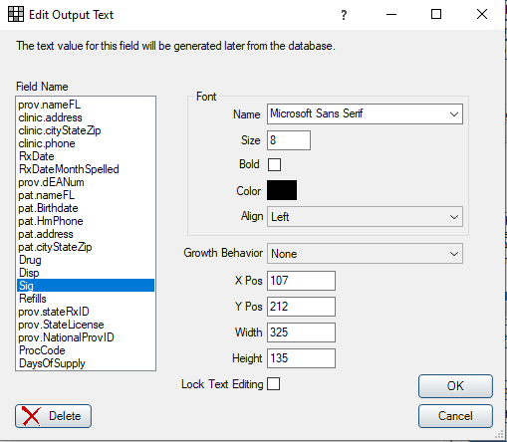

**Example Routing Slip:**

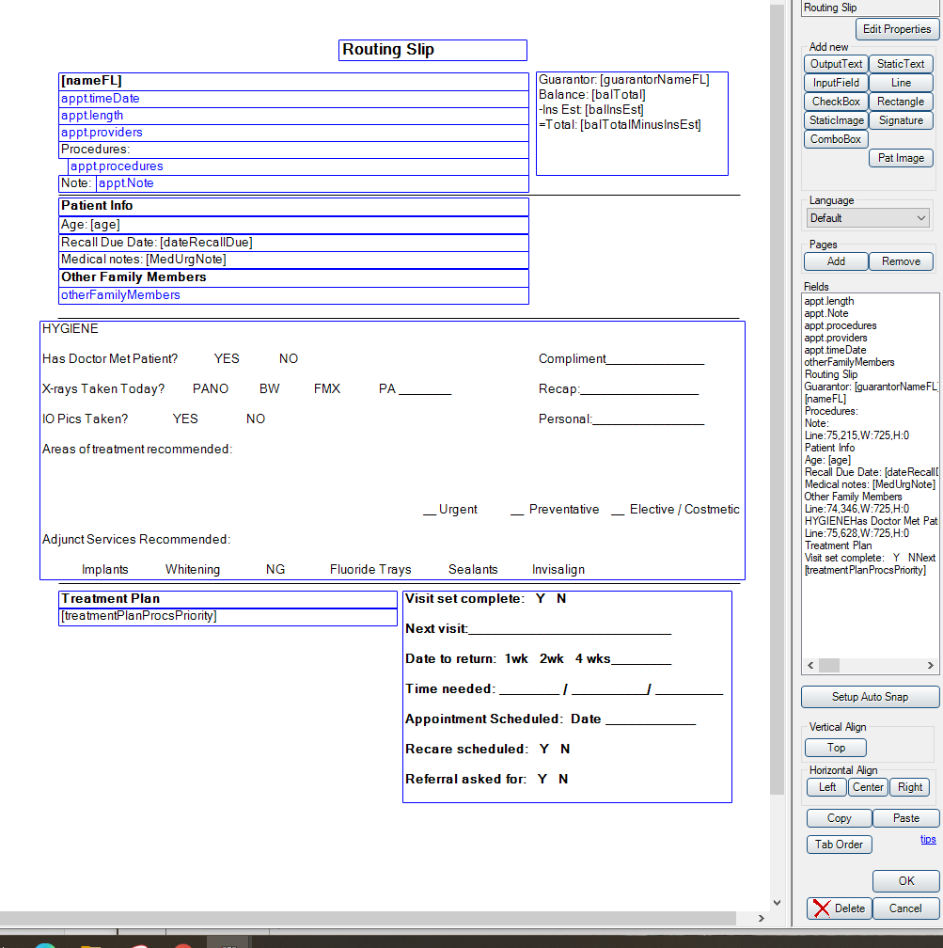

**15.** Educational Video Tracts for different positions (Coming Soon)

**16.** Medications List

* Follow the instructions in the video to upload

**17.** Backup Procedures & Best Practices (Coming Soon)

**18.** Splash Screen .jpeg

The splash screen appears briefly upon launching Open Dental.

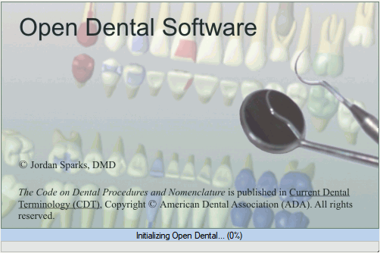

The image above is the default Open Dental splash screen.

In special cases, users may want to use their own custom the splash screen.

1. Create a .jpg file of your splash screen. The recommended image size is 500x300 px.
2. Name the file splash.jpg.
3. Place the file in the Open Dental program file on each workstation. This file will then be used in place of the original Open Dental splash screen.

**19.** Top Tricks

* Control ‘D’ = Date
  + Instantly putting in the date- any time, any place, Hit (Control D) and it will insert it
* You can open multiple windows of OpenDental at once
  + Usually have 2-3 open at a time for front desk users to not lose their place during some tasks, payment entering, etc.
* 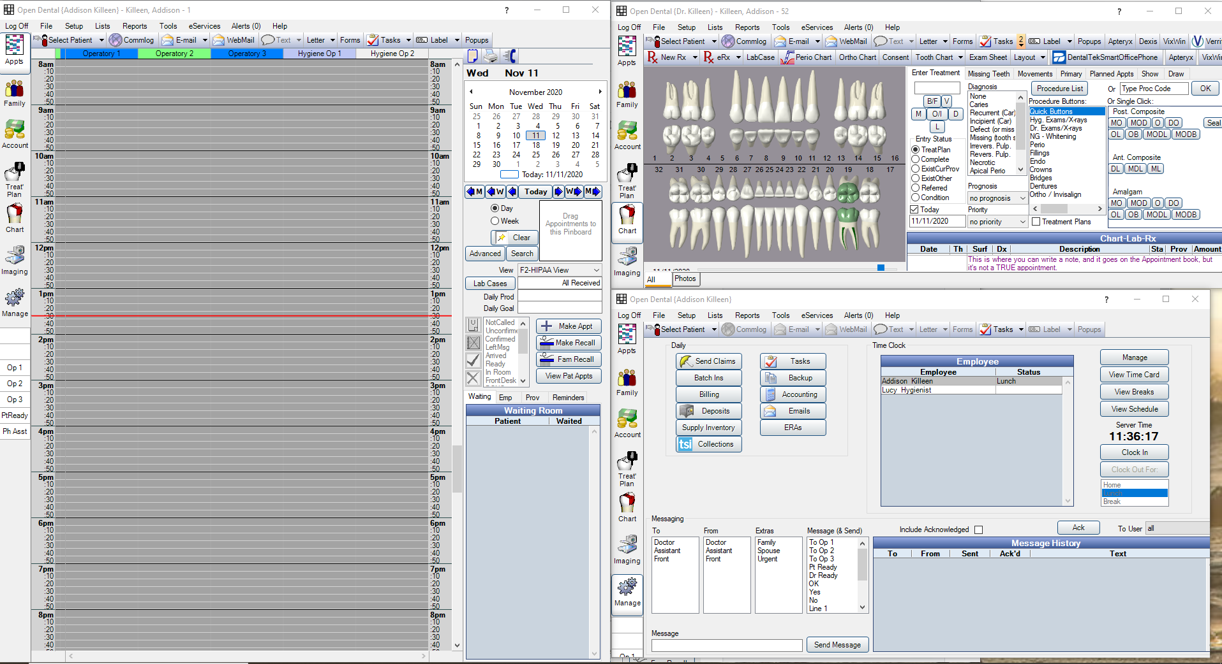
* Don’t accidentally Quit OpenDental
  + 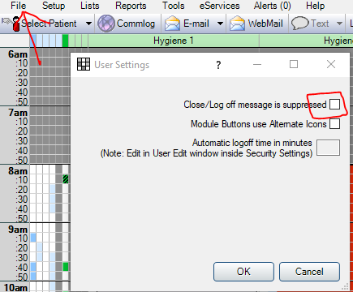
* Patient Notes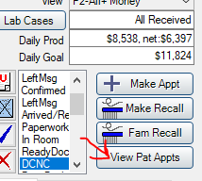
  + This process will allow you to put patient notes on the Appointment Screen without having a fake appointment. To start, click ‘View Patient Appointments’
  + Then ‘NOTE for Patient’
  + Then enter any note that needs to be remembered for the patient. 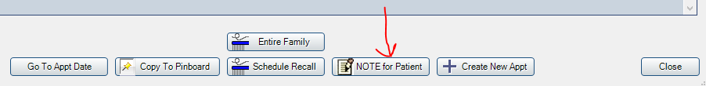

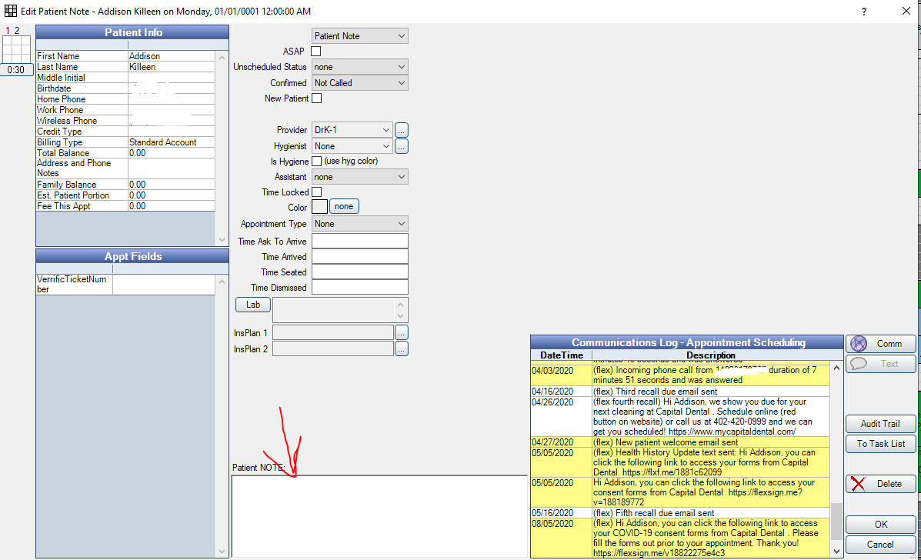

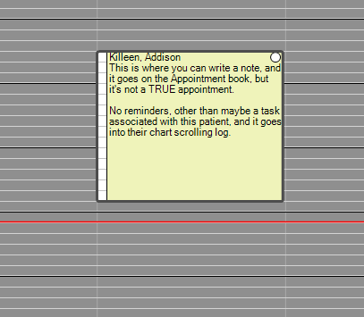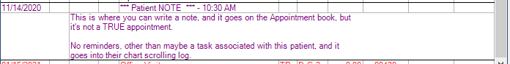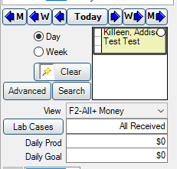

* + And remember that you can always set it to ‘Completed’ after you’ve completed the task/note!
  + It will then turn the note dark grey
* Waiting Room Time Turn Red
  + After X number of minutes, the time clock on the patient can turn red
* 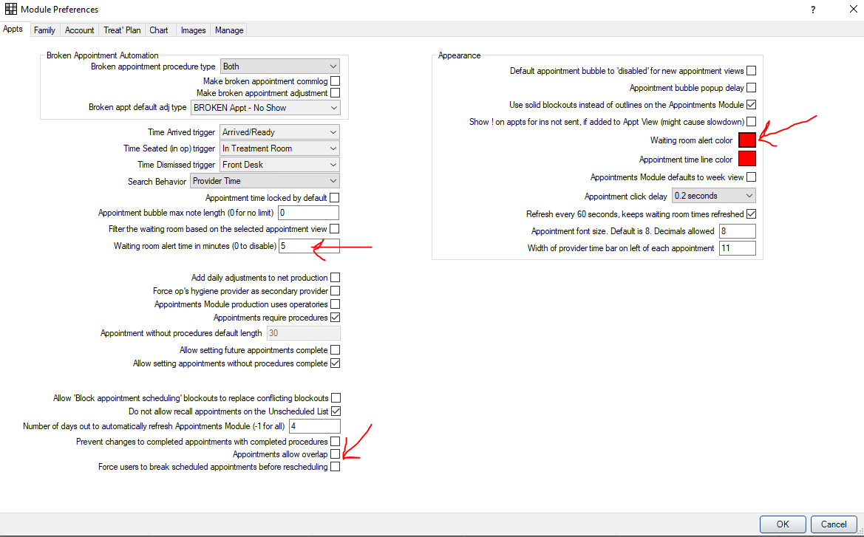
* Comm Log Colors
  + Change comm log colors for ease of viewing
  + 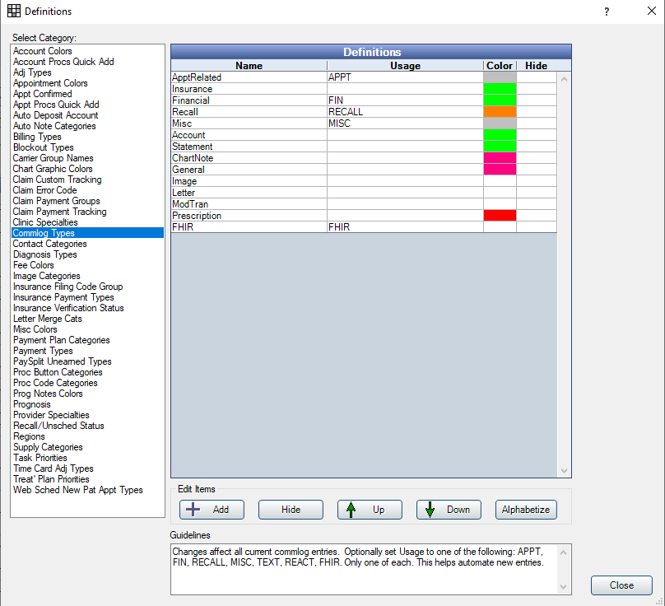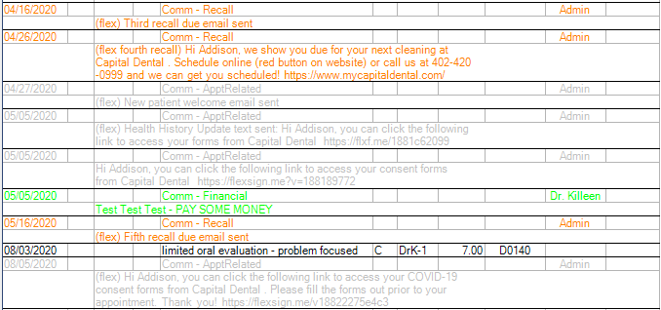
  + Viewing Settings on the Chart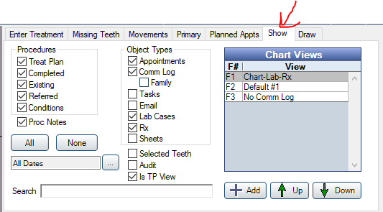
    - You can change settings on what to see on each computer
    - Make Pre-set and toggle using F1, F2, F3, etc.
    - 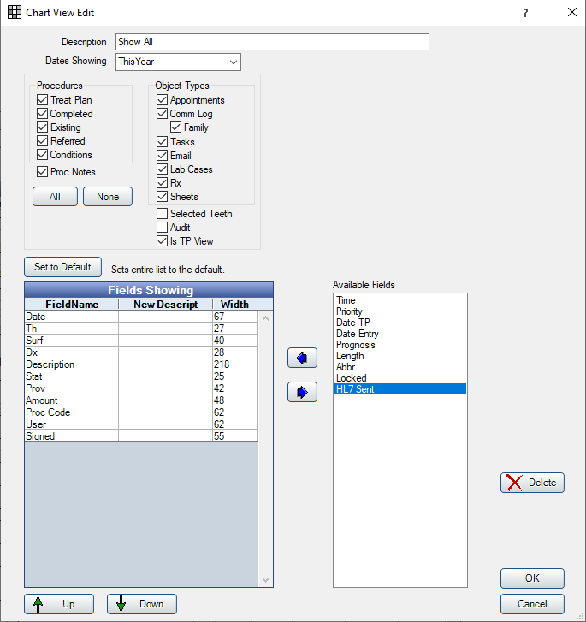
    - 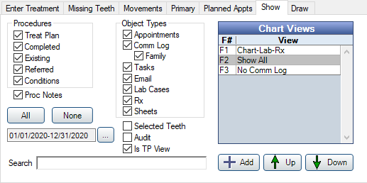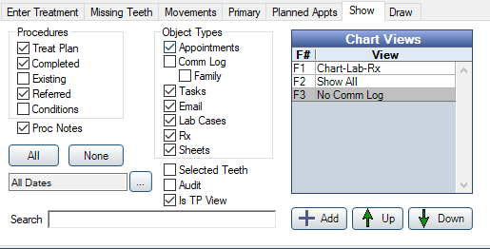
* Viewing the Patient DashboardTools- Patient Dashboard
  + Setup a Default one...then change to the information you want to show, example: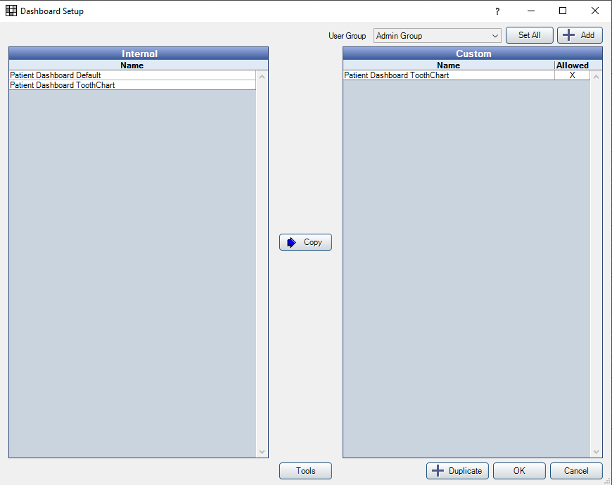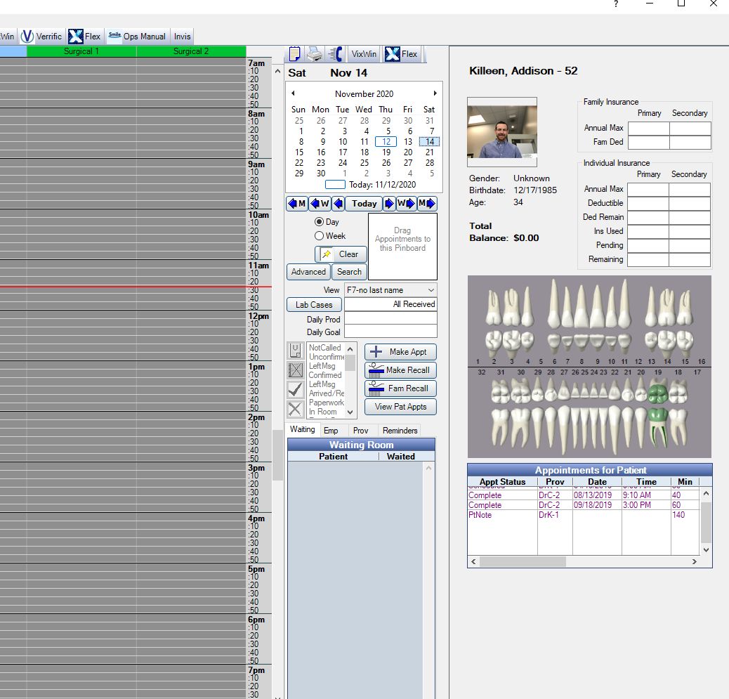
  + A Universal Example below

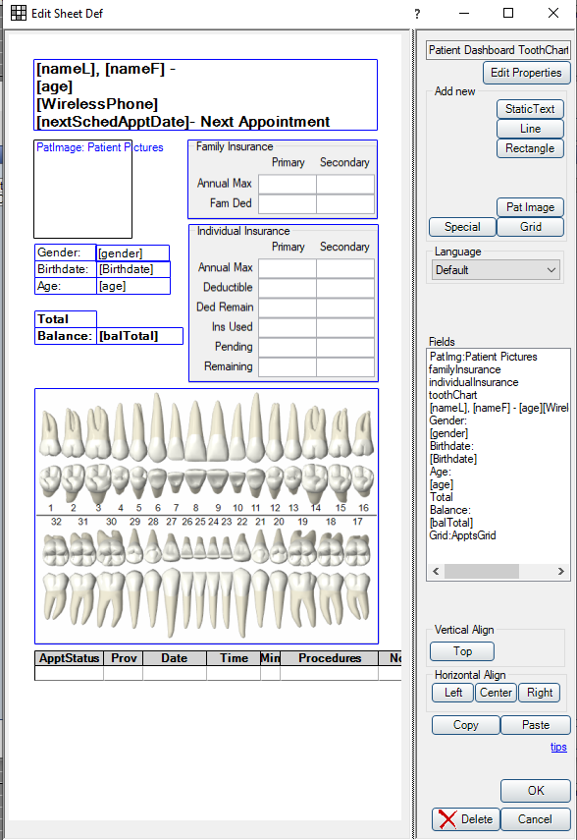

And then a HIPAA Compliant example for use in operatories:

